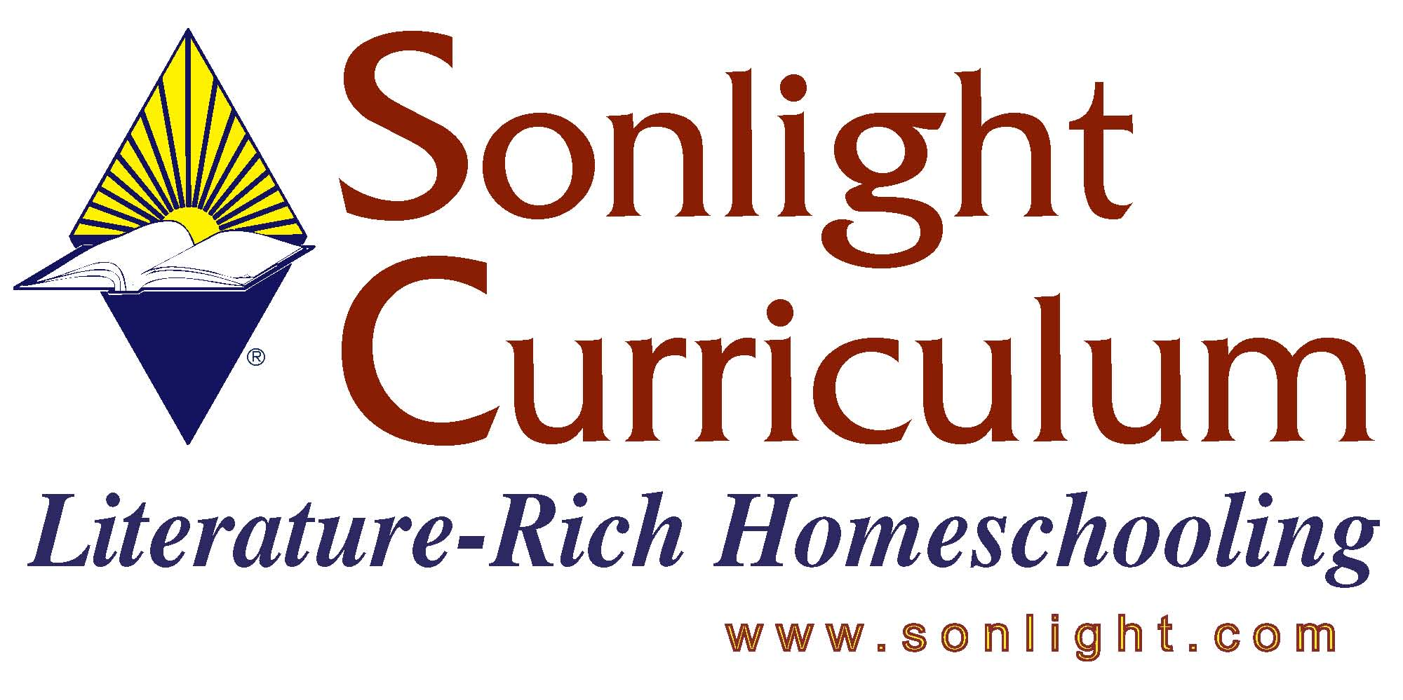

2006 – Product Fact Sheet

Title: Sequential Spelling
Reviewer: Linda Densmer

PRODUCT AUTHOR OR PUBLISHER: Don McCabe of AVKO Educational Research Foundation
(AVKO stands for Audio-Visual-Kinesthetic-Oral)
PRICE: $9.95

APPROPRIATE AGE RANGE OR READING LEVEL: 3rd grade and up. We recommend spelling through 8th grade.

What is included in this product? One instruction book with sequenced spelling lists and tests. Each volume is a full year’s spelling program. The only thing the customers needs to add is a spiral notebook for the student’s work and a white board or something similar.

Any special requirements necessary for using/teaching this product: All students who are new to the program should begin in Volume 1, regardless of age, because spelling is taught using carefully sequenced word families.

Give a 4-5 sentence description (or bullet points) of the goals or concepts this product teaches …
Sequential Spelling teaches spelling using base patterns, such as in, called “rimes” in academic jargon. Each lesson then builds word families by adding consonants, consonant blends, and digraphs, called “onsets”. So the first lesson introduces in, pin, sin, spin. By day 8 the last lesson in this family includes thinner, ins, inns, spinning, tin, skins, winner.

How do you fit this into a school day/how do you schedule this product:
Spelling is scheduled in the Instructor’s Guide

How much parental involvement? How much student time required at each session?
The parent gives each word in a sentence (the sentences are provided). The student writes the word. The parent writes the correct spelling on the white board. Student immediately corrects any mistakes. The parent gives additional instruction, as suggested in each lesson, on related topics (I is always capitalized, homophones are words that sound alike but have different meanings, etc.) As the student progresses, compare the current lesson’s correct spelling with previous attempts and praise the child for his progress.

This process should take 5-20 minutes for most children. Word lists start with 4 words and build to 25 words by day 9.

Name two or three things you feel it is important for customers to know about this product before they purchase?
As mentioned, all students who are new to the program should begin in Volume 1, regardless of age, because spelling is taught using carefully sequenced word families.

Each volume refers to AVKO Student Response Book. This is a specially designed book with lines for the student to write each day’s list. We are not offering this book, since a spiral notebook or similar tool works just as well.

The book also refers to The Patterns of English Spelling, a source book listing all word families in the English language. This resource is available from AVKO for $179.00. This is NOT necessary to use the Sequential Spelling program.

Reviewer’s Notes

