**SCC Connect – Thank You Campaign**

One of the first campaigns I would suggest that you launch with your SCC Connect program is contacting your customers to say thank you and/or welcome to the Sonlight family. I will show you the pieces that I created for my campaigns in the hopes that they will inspire you to create your own pieces and contact your customers. If you haven’t used SCC Connect yet, you may want to contact all of the customers who have purchased this catalog season – tell them thank you and remind them that you are available to answer their questions – and then continue to contact customers based on each month’s Sales Report or your quarterly Commission Statement. Once your campaign pieces are created, you can reuse them each month and it will just take minutes to set up once you have your report.

I set up two different marketing pieces to use in this campaign: one to congratulate first-time customers for choosing Sonlight and welcome them to the Sonlighter family, and one to thank returning customers for their purchases. There are a number of different Congratulations and Thank You pieces available for you to customize. They are found at Marketing Materials > eGreetings > Everyday.

Here is my Congratulations piece for first-time customers:

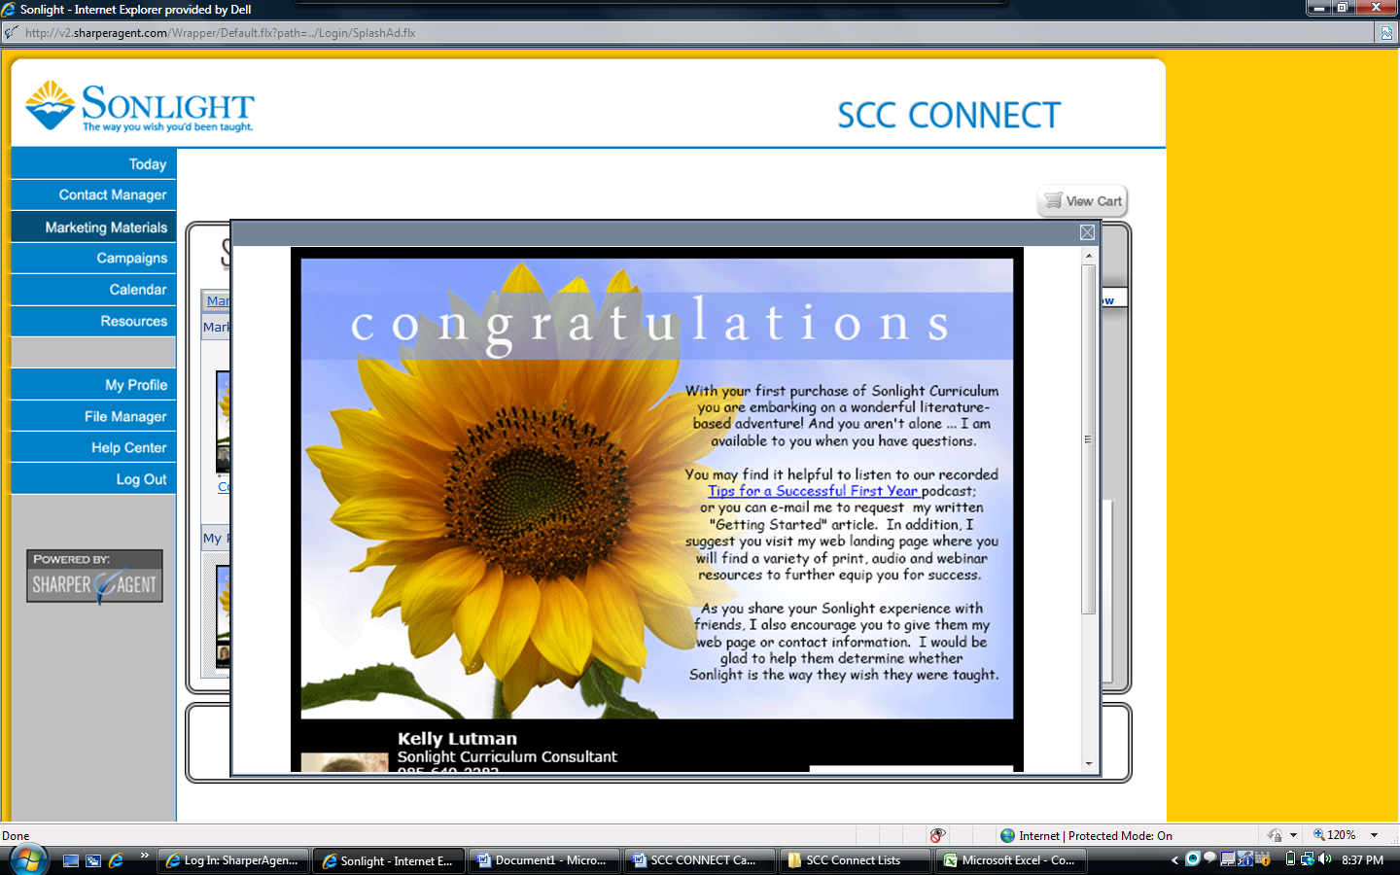

And here is my Thank You piece for returning customers:

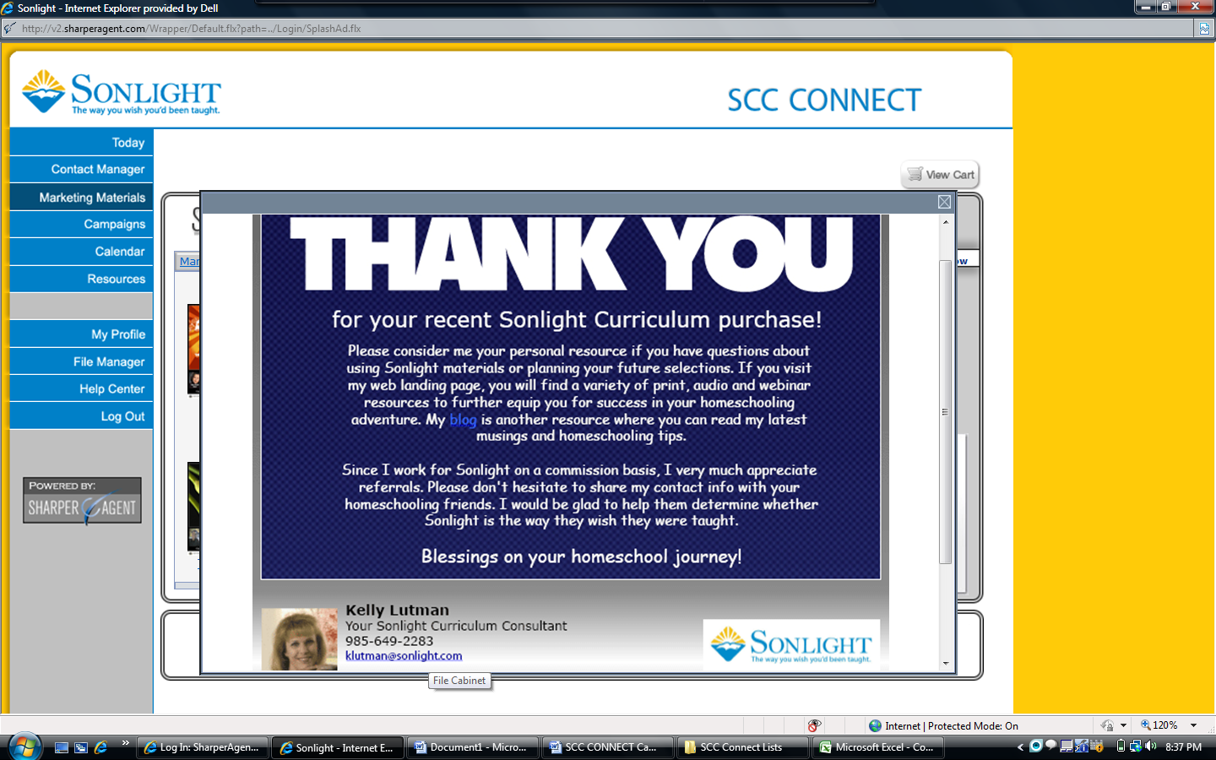

I have already created instructions for how to customize the Marketing Materials that are available in SCC Connect. Please refer to those instructions if you do not know how to make your own pieces after viewing mine.

What I will provide here is more specific guidance for taking your commission report or sales report and building a campaign from the data on them.

**Commission Statement**

Starting with your Commission Statement, copy and paste the new customer list from Sheet 2 onto a new sheet. Sort the list by customer name and then delete extra lines noting multiple purchases by the same customer. The goal is to obtain a list of customers who have made their first purchase. Next, copy and paste the residual customer list from Sheet 2 onto another sheet (I find it easier to have new customers and returning customers on separate sheets). As before, sort the list by customer name and delete any duplicate customer lines as well as any lines that note customer returns.

Taking the list you have created of new customers – you may find it easier to print the list so that you don’t have to jump back and forth between screens – begin the process of building your campaign. In the SCC Connect system, select “Campaigns” from the blue menu on the left of your home screen. Then click “Build a New Campaign.”

On the next screen, select the “Build Your Own Campaign” below the blue Campaign bar, then click the “Customize in Advanced Setup” to the right. On the next screen, below the “Add Campaign Elements” bar, click on the “Saved Pieces” tab, then select “eGreetings” in the menu. Select the saved piece that you wish to use in your campaign. A window will appear offering choices of action – edit, preview or add to campaign. If you haven’t just finished editing this piece, you may want to preview to ensure that it is appropriate for your purpose, then click “Add to Campaign” and the “Next Step” arrow.

Set up the details of the campaign, on the Delivery Options page:

* Choose the name for the campaign – make it unique so that you can identify it in your list of campaigns later.
* Since this will be a specific delivery date campaign, click radio button beside “Date Campaign.”
* Change the e-mail subject line. The system will automatically insert the title of the saved marketing piece but you want this to be personalized and welcoming so that the customer will open the e-mail.
* Schedule the date of delivery – at a minimum you will have to set delivery for the next calendar day, but you can set up campaigns several weeks in advance.
* Click “Next Step” arrow.

The next screen is where you will designate who will receive this marketing piece in your campaign. Working through your contact list, mark each customer (click in the box beside their name) who will be included in the campaign. Use the alphabetic list in the black column on the left to jump from one letter listing to another, then click on >> to progress through the customer names within that list. Or, type their name in the search box provided, then mark the appropriate customer in the resulting list. If you encounter a customer on your commission statement that is not in your SCC Connect list, make note of the name on your list and you can add it later.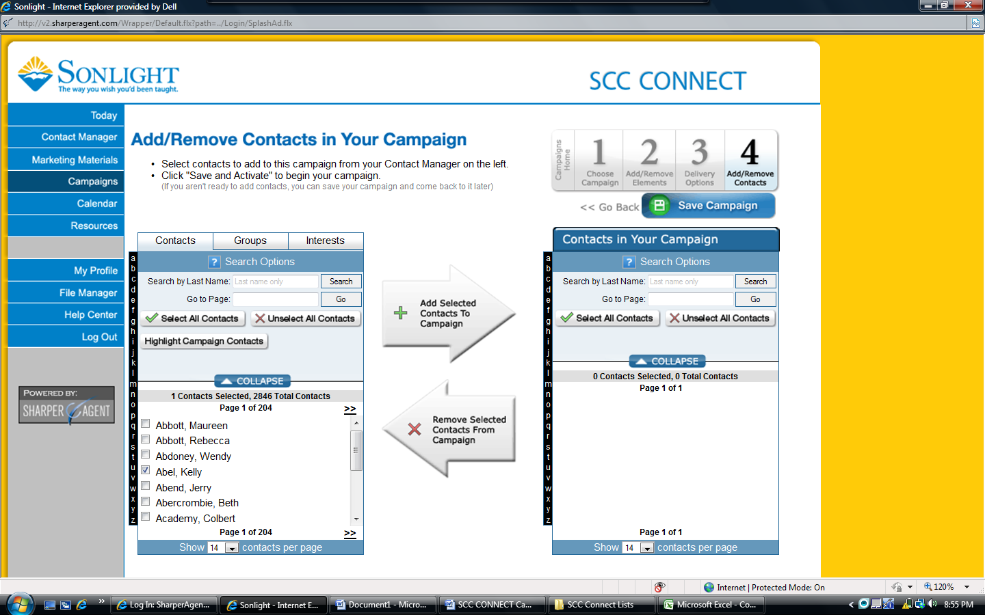

When you have finished marking the customers who are already in your SCC Connect Contact Manager, click on the “Add Selected Contacts to Campaign” arrow. A new window will appear that shows the verification of the contacts for the campaign. It also indicates the costs related to the campaign, which will be “0” unless you choose to do a print mailing. Under the Contact Verification header you will find the number of valid and invalid contacts – invalid contacts are usually those that did not have an e-mail address provided on your original prospect list, or those who have opted out of any prior e-mails and are now tagged in the SCC Connect system to not receive future e-mails. Click the box indicating that you have previewed the elements, then click the “Add Contacts to Campaign” button. [Note: When I have set up my campaigns, I get an error message, but clicking OK clears it and puts the contacts in the box on the right.] Click the “Save Campaign” button.

If you have not finished entering all your contacts, simply click Contact Manager in the blue menu on the right to begin the process of adding contacts from your commission statement. For the sake of e-mail campaigns, you can enter these contacts with just name, phone number and e-mail address, which is provided on the commission statement. Once you have added the remaining customers to your Contact Manager, click on Campaigns in the blue menu, and then click on your campaign in the listing and select “Add/Remove Contacts” from the drop down menu. Continue the process of locating and marking the customers that you just added to the Contact Manager, then click the “Add Selected Contacts…” arrow. Finish the process by clicking the “Save Campaign” button.

**Monthly Sales Report**

On the first spreadsheet of the Sales Report sort the data by First Order Date and Customer Name. Looking at the order date will enable you to determine whether the customer is new or returning and which campaign to include them in.

You can then add these customers to the campaigns you have set up based on the Commission Statement or set up a separate campaign if you are doing this monthly.

Monthly Sales Reports provide more information pertaining to what each customer purchases. You may want to create a campaign piece to send to customers who purchase a Core package, or set up your campaigns based on whether the customer is new or returning.

Updated 9/24/2011