**SCC Connect – Assist Inquiry List**

*Uploading this list is optional. You may choose to work with just your most recent contacts from this season’s events. Using your Assist list will require some sorting and gleaning, which can be time consuming. Briefly, these are items to consider:*

* *Start by thinking about your purpose for SCC Connect. What do you intend to do with it, what customers do you want to touch?*
* *You will want to weed out contacts that have never purchased – these can be identified by sorting the list by Last Purchase Date.*
* *You will need to separate your contact information onto separate sheets for each event so that they can be uploaded with a group designation.*
* *You will likely find duplicates because, unfortunately, Assist has several duplicate accounts.*

*These are some guidelines for processing your Assist customer listing from Barb for uploading to SCC Connect. In preparation for this process, you must request your list from Barb.*

You will receive an Excel spreadsheet listing all the customers from Assist with your SCC code on their account. The information will include their name, customer #, address, phone, e-mail, date added to the system, last order date, and territory (event code). Be prepared, if you have been an SCC for a long time, this may be a long list, but we will break it down into more usable portions in the following steps.

I recommend that you sort out the list information into smaller portions by events and then copy each event’s data into a separate Excel file which will be saved in .csv format for uploading to SCC Connect. Suggested approach for sorting the information to upload to SCC Connect:

1. Sort the spreadsheet date by event code and last order date. I would suggest that you label this first sheet “Master” by right clicking on the “sheet 1” tab at the bottom of the screen, selecting “Rename” and typing “Master.”
2. Now label the second worksheet in the file “Personal” and label additional sheets with each event code in the Assist listing - in the same way that you changed “sheet 1” to “Master” you will change “sheet 2” and others as needed.
3. Copy and paste the Master spreadsheet header onto each additional sheet by highlighting the header titles on your Master page, Ctrl+C, then clicking on the top left cell of the new page and Ctrl+P.
4. Copy and paste the “Personal” customers’ data onto the “Personal” sheet, and then each separate event onto the appropriate sheet.
5. Once you have the Master list separated, you can review each event’s customers to determine whether you feel they are contacts you may want to keep in touch with, or whether they can be omitted.
   1. Contacts who have never ordered should be at the top of the list (after they have been sorted by last order date) – if they haven’t ordered in 4+ years since you contacted them at an event, do you feel that they are still prospects who warrant additional touches? Those that you do not wish to upload to SCC Connect can be deleted from the spreadsheet (their information will still be available your Master listing should you want to reference them again).
   2. Consider what campaigns you may want to set up – thank you notes to current purchasers, an offer of consult for contacts who have not purchased yet, a touch for customers who haven’t purchased in a few years, etc.
   3. As you plan your campaigns, make notes of the group labels you would want to use in SCC Connect in order to identify customers who would be included in the campaigns. For example, my groups include Personal Contacts, FPEA Past (these are contacts from the Assist listing), FPEA 2010 (these are contacts from this year’s event – uploaded from my prospect list), CHEF AL Past (this is an event I no longer do, but I still have customers from it), and 2010 Purchasers. I did find duplications when I uploaded the FPEA Past and FPEA 2010 lists because of contacts who have come to the booth for many years, but I wanted to keep those customers (even long-term ones) noted in my 2010 contacts if they are still coming to the booth. I also add each customer from my monthly sales reports to the 2010 Purchasers group so that I know they are active customers.
6. Once you have cleaned out your event contact lists, I recommend that you change the formatting of the information from all caps to the traditional format, so that it will look “normal” when you correspond with your customers. You can use Excel to change your Prospect List to the mixed-letter format with the "Proper" function.
   1. Click on the top of the column you need to correct and then click insert to put a new column to the left of the one you need to correct, making sure it is in General format.
   2. In the first cell, enter "=PROPER(cell#)" using the specific cell # that you are correcting and hit return. For example, if you are working on the Wife's First Name in your Assist listing and have clicked on the top of that column and then inserted a blank column B to work in, you would probably be referencing cell C2 for correction.
   3. Click back on the cell where you entered the formula (B2) and the cell will have a box surrounding it, with a small square in the lower right corner. If you click on that square and drag it down the column to the bottom of the data that you are correcting, Excel will copy the formula for all of those cells.
   4. Copy/paste the column title from the column you were correcting to the top of your corrected data.
   5. You have now created a correctly-formatted column of data which can be used for your prospect list. Click on the top of that column and insert another blank column to the left. Now click and drag to highlight the content of the corrected column (header included), then hit CTRL+C to copy it. Click in the top cell of the blank column and then click the drop-down arrow under "paste" in the Clipboard section of your Home toolbar, and select Paste Values. Your newly formatted data should copy into the column. Now you can delete the original column and the formatting column (the two columns to the right). If the data in the newest column changes after you delete the two columns, you most likely missed the Paste Values step and would need to undo your last several actions and re-copy the correctly-formatted data using Paste Values from your clipboard menu on the left of the Home toolbar.
   6. Repeat these steps for each column that needs to be replaced with upper/lowercase letters – I changed first name, last name and address columns.
7. For each of these event groups, you will open a new Excel file and copy the header line and data into the file. The easy way to do this is the click on cell A1 on the event sheet and drag your mouse down and across the page until you have highlighted the header and down to the bottom right corner of the data. Hit CTRL+C, then go to the new Excel file and click in column A1 and hit CTRL+P. All the columns and rows should copy into the new file.
8. Save the new file in .csv format with a name that clearly notes it for SCC Connect data, such as “SCC Connect *event name* Past”.
9. Now we begin the process of uploading your files to SCC Connect. This information was also covered in the webinar that is posted on the Wiki, but I will include basic instructions here.
   1. In your SCC Connect system, click on the “Import Contacts” button at the top of your contacts screen. You will then select the type of file you will be importing – Excel is at the bottom of the list. Click “Next”.
   2. On the next page you will select the group designation that will be assigned to the contacts you upload. If you don’t already have your group entered, you can click on the “Add New Group” link and put it in. Then click on the appropriate Group name in the list, and browse your system for the spreadsheet from which you will upload. I find it easier to save all of these spreadsheets in a SCC Connect folder in My Documents. Once the document is referenced for uploading, make sure the field delimiter is noted as “Comma delimited” and you check the box noting that the file has a header row. Click “Submit”.

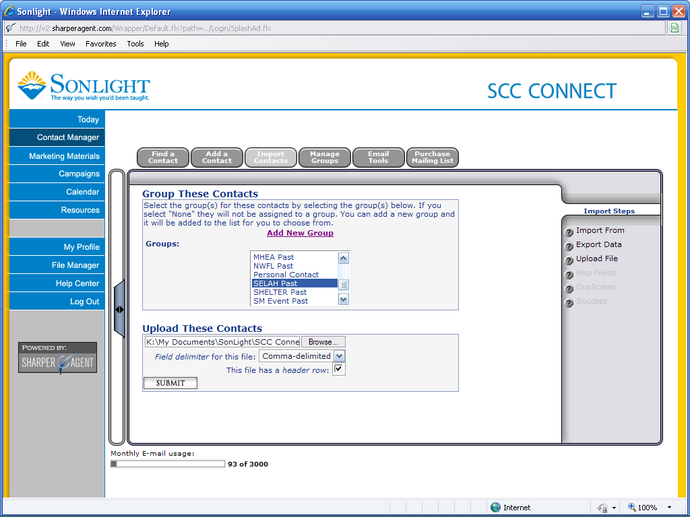

* 1. The next page will ask you to designate what header columns will feed the information on the contact manager. I generally note First Name, Last Name, E-mail, Address 1 (on line for Street Address Name), State/Country/Zip will automatically fill, and Phone. If you know that you had entries in the Address 2 line, you can fill that one further down on the Address 2 section.
  2. When you click the Upload button, the system will show you a preview of the data it is pulling. Scroll across the lines to ensure that the data you want is shown and not duplicated or misformatted, then either modify your data field designations or move on to check for duplicates.
  3. The next step is to check for duplicate entries. Click on the button, then scroll down to tell the system whether you want to check by e-mail or name, and click “Accept”. The next screen will show you the entries you are trying to upload that would duplicate data already in SCC Connect. When you float your curser over the e-mail address or name on the right of the screen, a new window will pop up that shows what you have in your import list and what is already in the contact manager. You can then decide whether to “Abandon,” telling the system to ignore that record in the upload, “Import,” telling the system to create a new record even though it will duplicate a customer in your files (you can go back later and delete one of the records manually if you make note of the name), or “Replace,” telling the system to replace the current information on the customer with the new record. Once you have reviewed the full duplicate list, click “Submit These Decisions” and the system will complete the upload process.

1. If you have not uploaded your event Prospect Lists to SCC Connect, it should be sufficient to just load the Assist history that you receive from Barb. If the Assist listing was requested after your events were finished for the year, it will include the prospects from this year’s events. Once the data is sorted and uploaded, you are ready to begin experimenting with campaigns. My recommendation for your first campaign would be to send a Thank You to your customers who have purchased. I do this each month, but you may want to word your marketing piece as a thank you for purchasing for this school year and include encouragement for the school year and your offer of assistance. I will create a separate document providing guidance on doing this particular campaign.

If you have questions about SCC Connect, contact Kelly Lutman.

Updated 9/24/2011