SCC CONNECT – Customizing Marketing Materials

You have a variety of options in marketing material to use in your e-mail campaigns to customers and contacts from conventions. Sharper Agent has now cleaned out the pieces that are clearly related to real estate, leaving us with less clutter in our options. Still, I would expect that most anything you would send out to contacts would be customized, except for post cards that offer recipes or reminders for time change, etc.

There are several different categories of marketing materials that can be sent via e-mail. These include a wide range of eGreetings that would appear as postcards on your e-mail, Postcards, Newsletter formats, and Flyers. The eGreetings category offers the largest selection, in Professional and Everyday options.

SCC Connect was recently (late March 2011) upgraded so that their editing interface is more flexible than it had been. I am updating these instructions to guide you through the new system.

As an example, I will show how I created the piece that I send as a reminder about the coupon and offer of assistance to those who attended a convention this season. Here is what it looks like when I first select the piece from the eGreetings options and click on “Create/Edit” in the preview box:

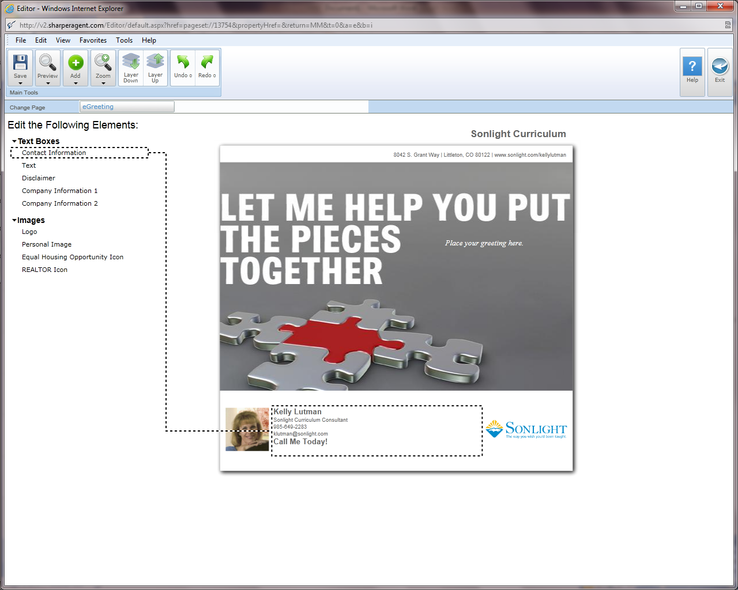

When you float your curser over editable portions, the system highlights the appropriate section. Click when the section you want is highlighted and it will be opened as an editable window, with the text edit toolbar appearing above.

I’m going to start with my contact information box at the bottom of the piece. You can vary the size or color of the font, or change the font altogether. Editing is done much like working in a word processing document. Here is what I did:

Kelly Lutman

Sonlight Curriculum Consultant

985-649-2283

klutman@sonlight.com

Call me with your questions - I'm here to help!

Of course, you can adjust your information in any way that you feel is appropriate. I do recommend that you drop the call to action line (seen as the default “Call Me Today!”) lower than your contact information and make it more specific. When you are done with this section, simply click outside the marketing piece and you are ready to select another section. I will be working on the main Text box next. To do so, I click on the “*Place your greeting here*” notation and, again, the text editing toolbar appears.

I will simply start typing my message and when complete, work on editing its appearance. The text box will expand as you continue to type your content. When you have finished typing, you can go back and highlight portions that you want to adjust – changing the font, the size, the color, etc.

If you will be preparing several pieces with similar content, you can save time by highlighting the text and then clicking on “Save as Article” in the toolbar above. You will be asked to give this ‘article’ a name, and then it will be saved in your articles file. You can then duplicate that text in a new piece by clicking on “Load Article” and selecting the appropriate title from the listing.

There are a variety of additional features that you may want to explore. If you were creating an invitation to a workshop, you can imbed a Google Map on your marketing piece by clicking “Add”, selecting Google Map, and following instructions. You can layer images up or down, add symbols, hyperlinks, etc. The possibilities are about as varied as your ideas, so explore.

When you are done, I recommend that you click “Preview” and “E-mail” to see what your piece will look like. Make any further adjustments and then “Save” your piece with a title that you can recognize.

The next step is to set up your campaign and get your piece out to your contacts. Look for separate instructions for setting up campaigns.

Below you will see my finished piece …

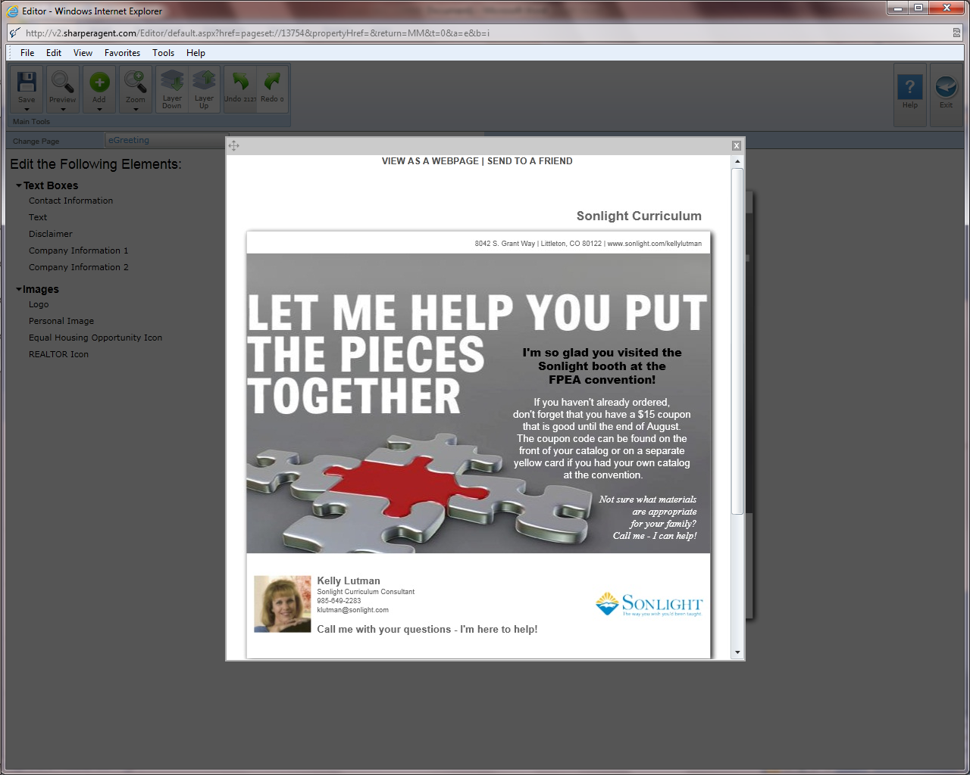

Created 6/21/2011