**SCC CONNECT – Creating Campaigns**

Before you begin setting up the campaign, I suggest that you add yourself to your Contacts (at least your name and e-mail address) and attach yourself to each of the groups to which you will send a campaign. That way you can see what your customers receive and ensure that the campaign is being sent in the way that you intended.

Select “Campaigns” from the blue menu on the left of your home screen. Then click “Build a New Campaign”.

On the next screen, select the “Build Your Own Campaign” below the blue Campaign bar, then click the “Next” arrow on the right side above the blue bar. A pop-up window will appear telling you that you have to used Advanced Setup, click OK. Below the “Add Campaign Elements” bar, click on the “Saved Pieces” tab, then select “eGreetings” in the menu.

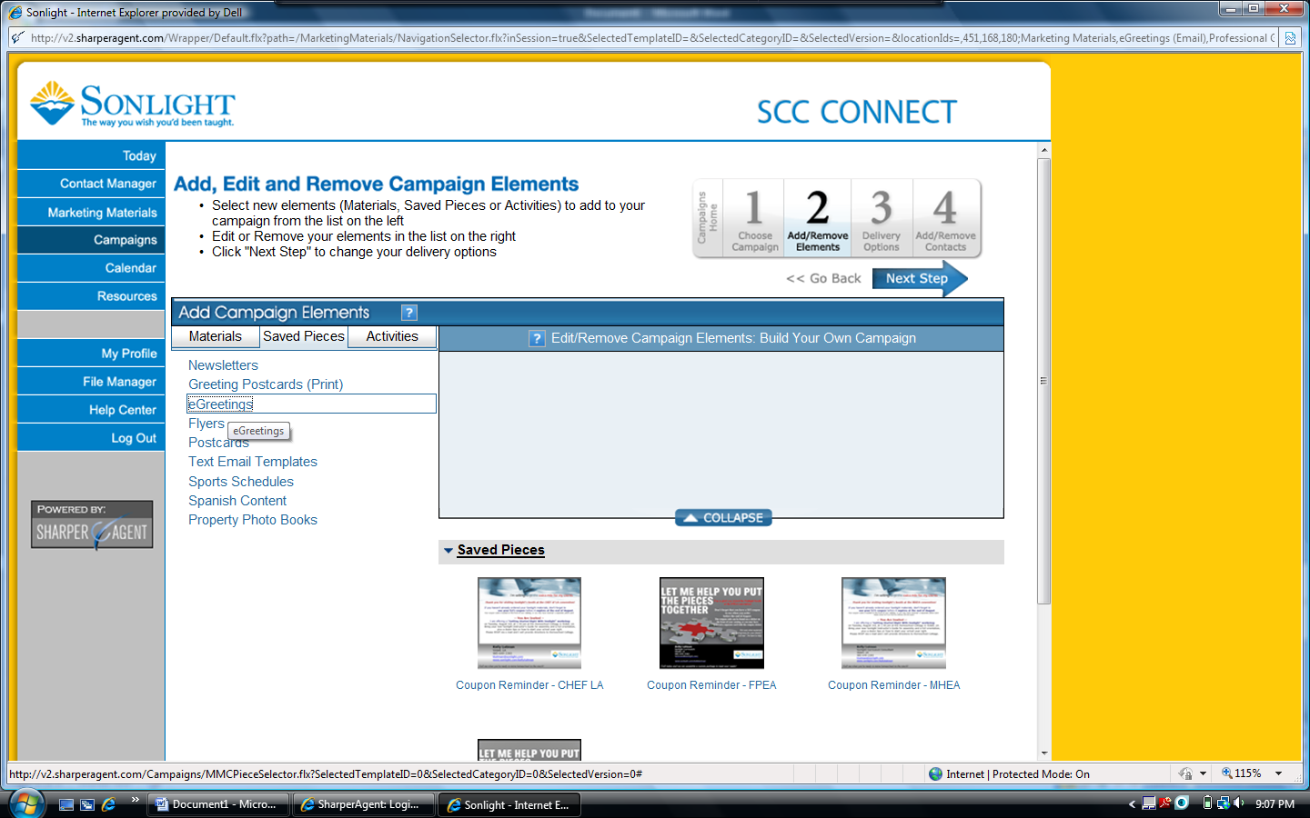

Select the saved piece that you wish to use in the campaign. A window will appear offering choices of action – edit, preview or add to campaign. If you haven’t just finished editing this piece, you may want to preview to ensure that it is appropriate for your purpose, then click “Add to Campaign” and the “Next Step” arrow.

*…. more below ….*

Set up the details of the campaign, on the Delivery Options page:

* Choose the name for the campaign.
* Since this will be a specific delivery date campaign, click radio button beside “Date Campaign.”
* Change the e-mail subject line (the system will automatically insert the title of the saved marketing piece).
* Schedule the date of delivery – must be at least one day after the date when you set up the campaign, but you can set these up well in advance and the system will send later.
* Click “Next Step” arrow.

Hang in there … almost done! ☺

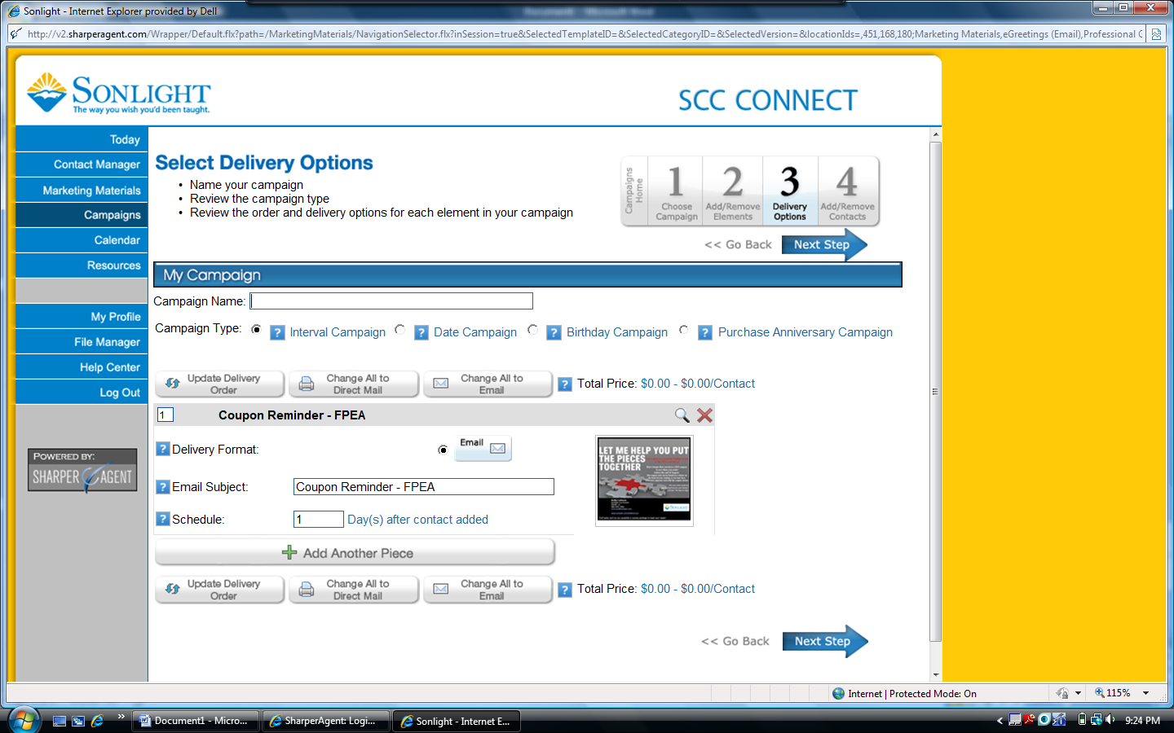

The next screen is where you will designate who will receive this marketing piece in your campaign. Following the example that I have provided, I was sending this piece to all of my contacts from the FPEA convention. I had already followed the instructions provided in the first training webinar and document to upload the contacts from my prospect spreadsheet and connect them to the FPEA group so that they are in my SCC Connect system to use in campaigns.

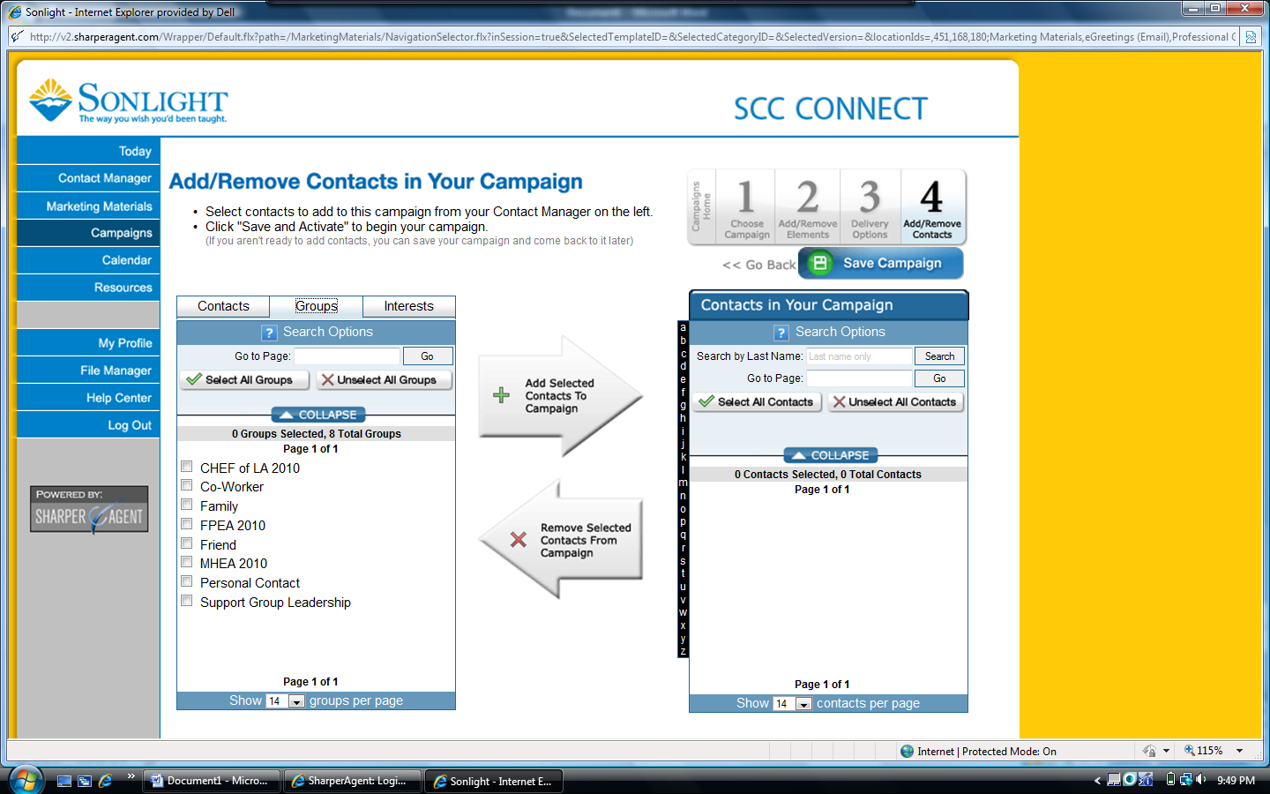

In the left box, click on groups then click on the box beside the group you want to use. In other situations, you could work from individual contacts listing, adding them to your campaign contacts for more specific mailings.

After the recipients have been selected, click on the “Add Selected Contacts to Campaign.” A new window will appear that shows the verification of the contacts for the campaign. It also indicates the costs related to the campaign, which will be “0” unless you choose to do a print mailing. Under the Contact Verification header you will find the number of valid and invalid contacts – invalid contacts are usually those that did not have an e-mail address provided on your original prospect list, or those who have opted out of any prior e-mails and are now tagged in the SCC Connect system to not receive future e-mails. Click the box indicating that you have previewed the elements, then click the “Add Contacts to Campaign” button. [Note: When I have set up my campaigns, I get an error message, but clicking OK clears it and puts the contacts in the box on the right.] Click the “Save Campaign” button.

Once you have set up your campaign(s), you should see them listed in a menu when you click on “Campaign” from your SCC Connect home page. You can see the campaigns that I have set up, along with the scheduled delivery dates and status, and the number of contacts reached.

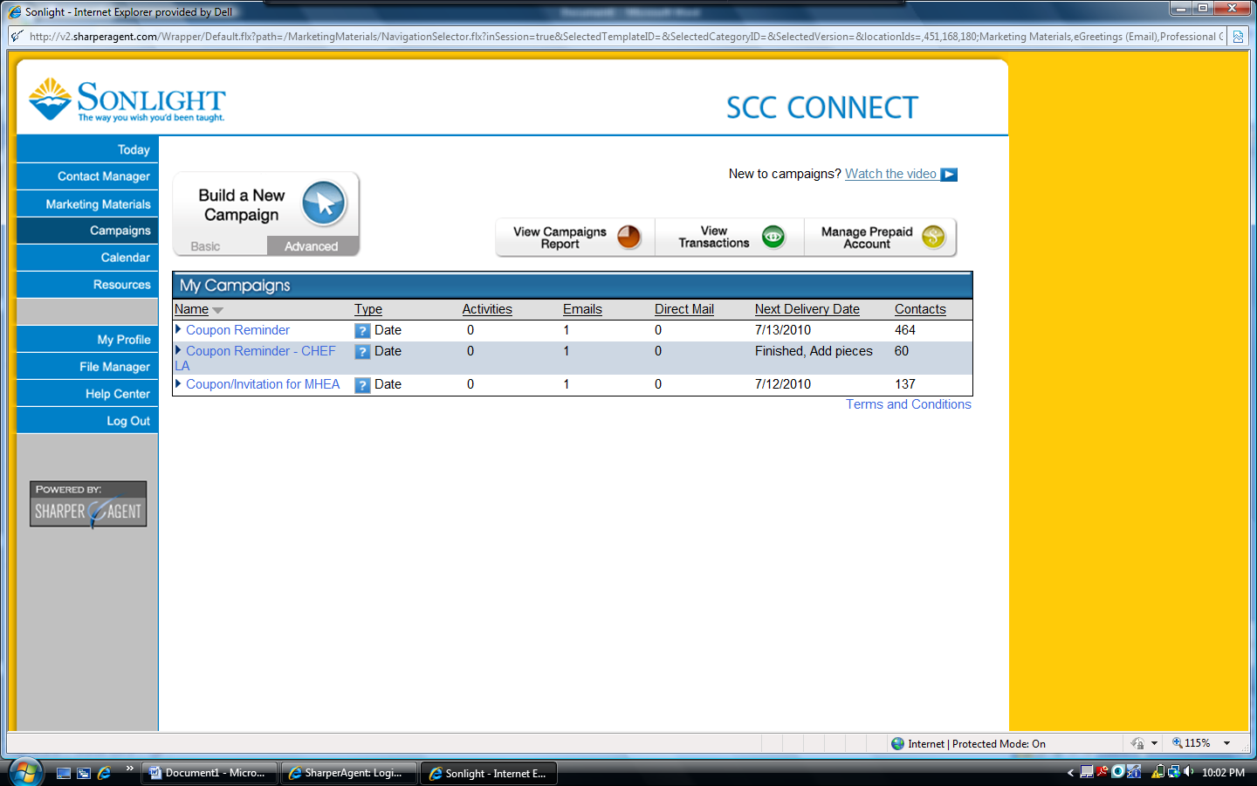

Once a campaign has run, you will receive a recap e-mail from Sharper Agent telling you how many e-mails were sent and how many of these bounced back (due to incorrect address), or resulted in an unsubscribe request or a spam complaint. The SCC Connect system is designed to send the e-mails individually so that it should not result in a spam appearance; however, in the 3 campaigns that I have now run, I did have one spam complaint reported.