**SCC CONNECT – CAMPAIGNS**

Since most of us will not be using the print/snail mail approach to campaigns through SCC Connect, this training will focus on using eGreetings or e-mails.

**eGreetings**

While there are a number of predesigned marketing materials that are suited just for real estate sales, there are several that can be adapted for our use. These can include:

Marketing Materials > eGreetings > Professional Greetings > Prospecting

Count On Me

Look Me Up

Let Me Help You Put Pieces

Extra Mile

Marketing Materials > eGreetings > Professional Greetings > Referrals

Referrals Are Appreciated

Send Them My Way

Marketing Materials > eGreetings > Everyday > Invitation

Marketing Materials > eGreetings > Everyday > Thank You

**Customizing the Marketing Materials**

Select the piece that you wish to explore by clicking on the link below the picture, then click “Preview” in the column to the right. To personalize the piece, close the Preview window and then click “Create/Edit” on the right.

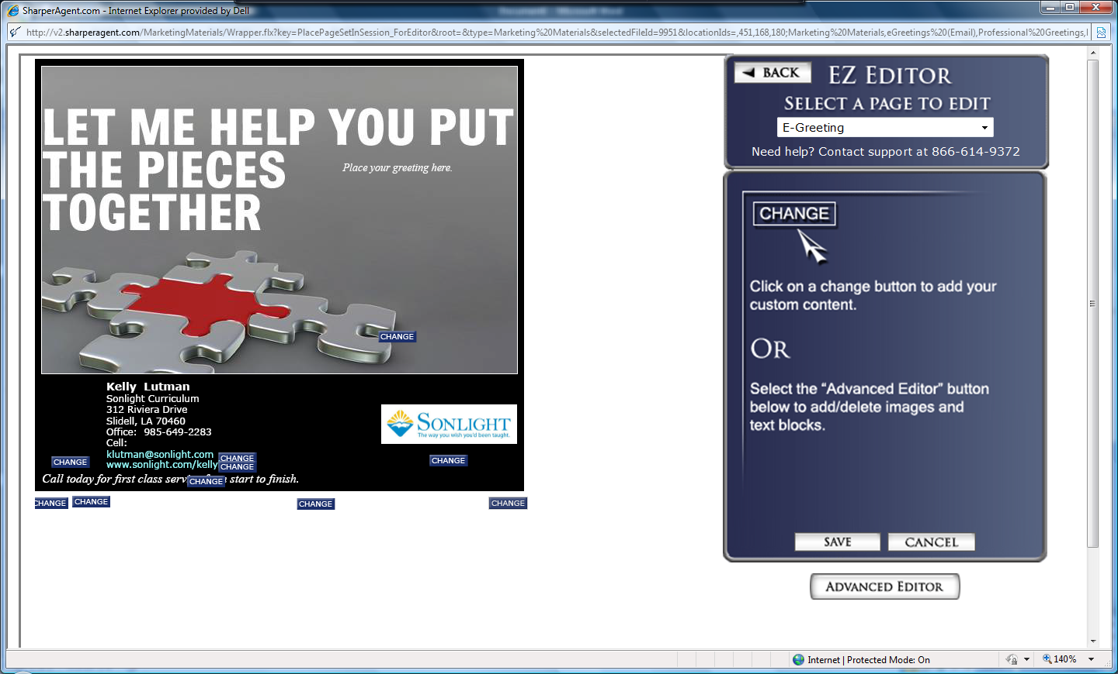

Notice that your information is automatically put into the piece from your profile. This can be modified when you edit the piece. Select “Advanced Editor” button at the bottom of the right column.

The Advanced Editor will allow you to change segments of the piece by clicking on the change button located in that segment. The first change that I would recommend is modification of your contact information. Click on the “change” button beside your e-mail address. This will open the editor box which allows you to change the font, font size, color, and position. If you wish to change the size of the textbox, use the height or width +/- buttons in the “Modify This Textbox” section. Be sure that your font color is easy to read against the background.

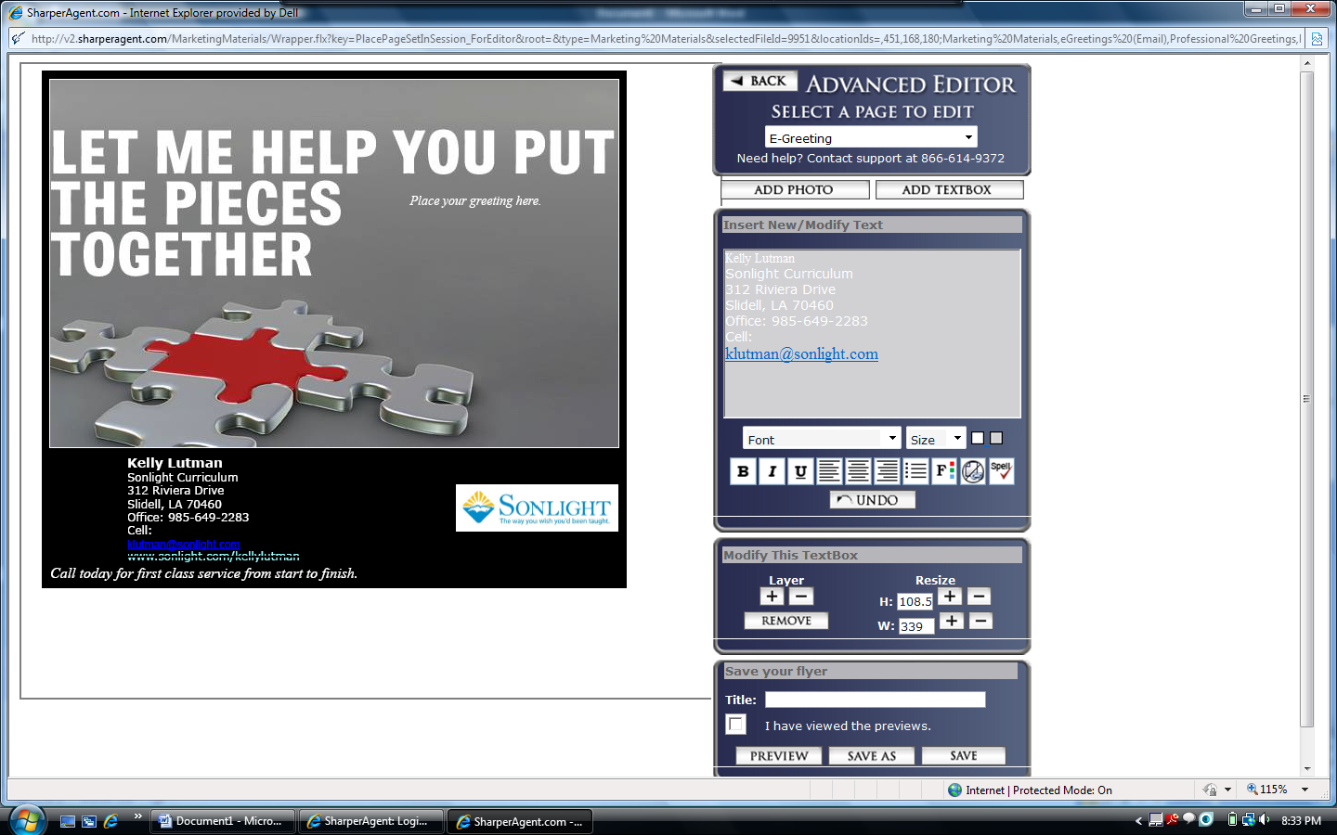

You will probably want to change the tag line at the bottom of the piece, as well as the general message in the main part of the piece. As you make your changes, they will appear in the sample on the left. At any time during the modification process, you can click the “Preview” button at the bottom of the page. When you have completed your modifications, check your work with one last “Preview”, then type your title in the appropriate box, click the box indicating that you have previewed your work, and then click “Save As” to save your piece in eGreetings section.

I used this marketing piece with modification to send to convention contacts to remind them about the coupon code (and where to find it) and encourage them to contact me if they needed help determining what Sonlight materials would best fit their needs.

Since I attended several different conventions, I modified this piece for each convention and saved it with the convention name so that I could use it in individual campaigns with each convention contact group.

Here is a sample of my modified marketing piece:

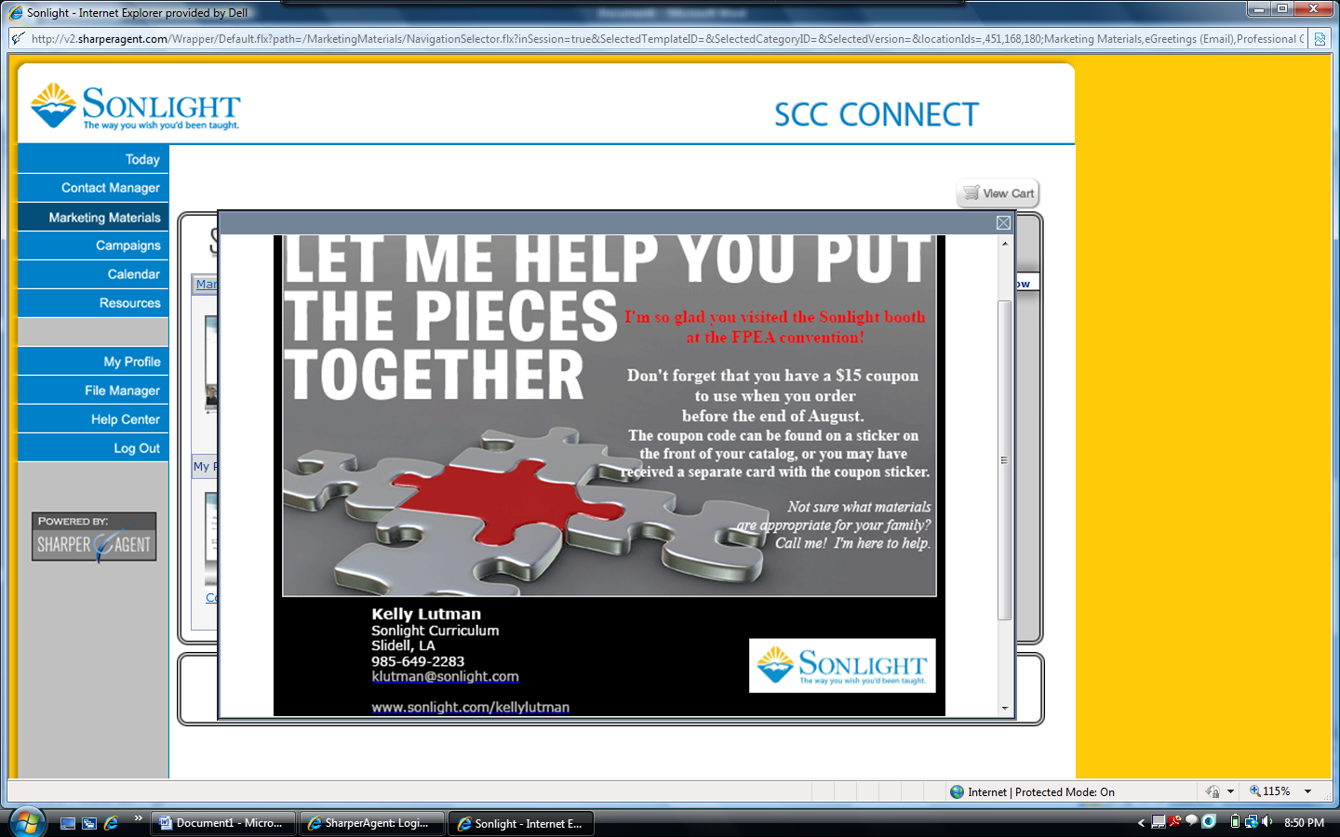

Based on response that I have had from my first event’s campaign, I would suggest that you adjust the wording to say something like “if you haven’t already ordered…” I had one customer reply that she had already used her coupon and she thought that we shouldn’t be sending the reminder when someone had already ordered.

If you offer workshops in your area, you might modify one of these pieces to send out as an invitation. There are a variety of opportunities to send a touch to your customers, whether it is a colorful, designed piece such as this sent after you have received notice of a customer’s purchase to thank them, or a personal e-mail noting exciting news from Sonlight (assuming that they would not have already heard directly from Sonlight).

Whatever the occasion, sending these pieces out requires that you set up a campaign.

**Setting Up Campaigns**

Before you begin setting up the campaign, I suggest that you add yourself to your Contacts (at least your name and e-mail address) and attach yourself to each of the groups to which you will send a campaign. That way you can see what your customers receive and ensure that the campaign is being sent in the way that you intended.

Select “Campaigns” from the blue menu on the left of your home screen. Then click “Build a New Campaign”.

On the next screen, select the “Build Your Own Campaign” below the blue Campaign bar, then click the “Next” arrow on the right side above the blue bar. A pop-up window will appear telling you that you have to used Advanced Setup, click OK. Below the “Add Campaign Elements” bar, click on the “Saved Pieces” tab, then select “eGreetings” in the menu.

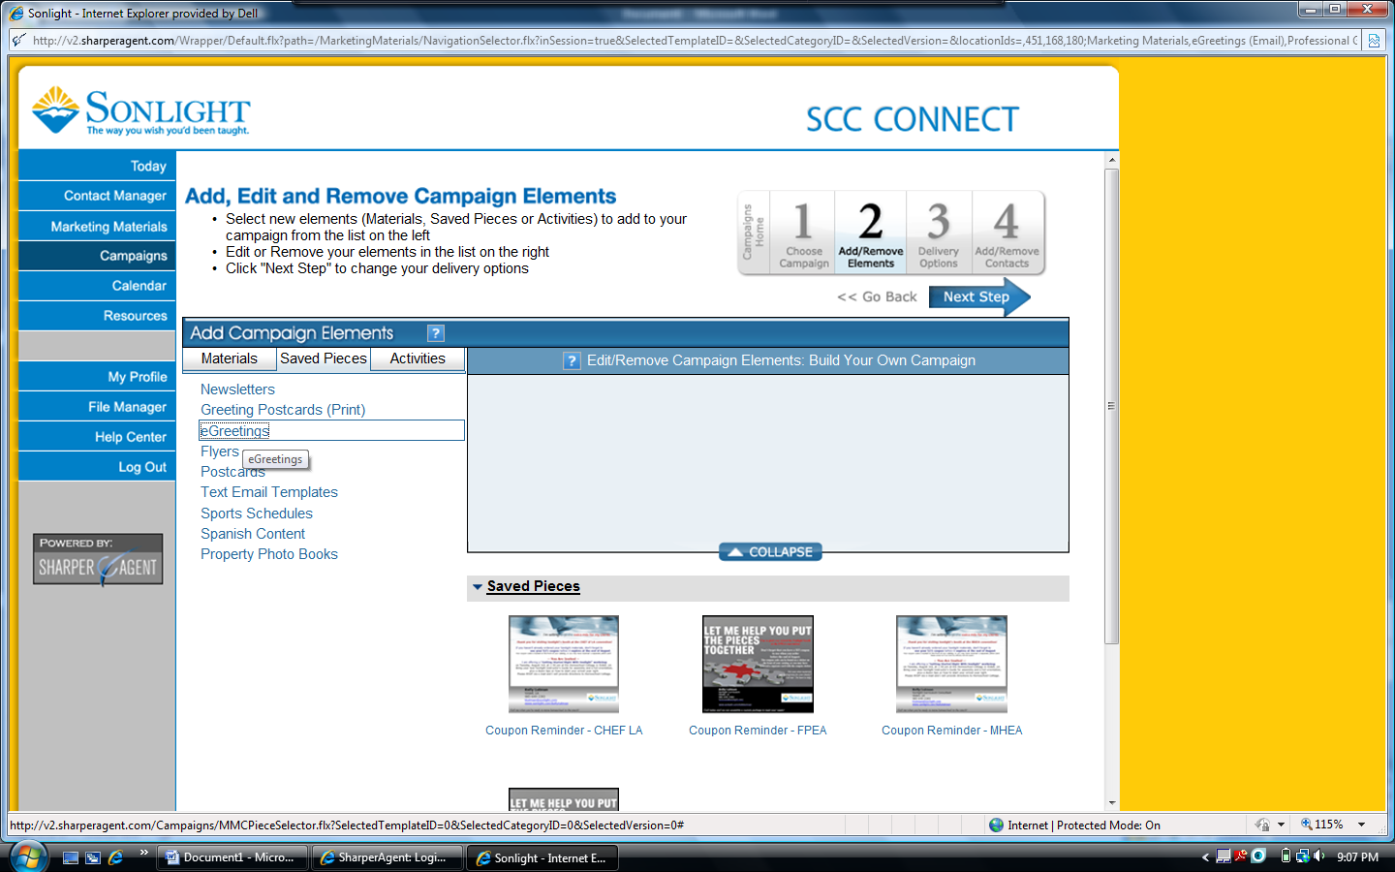

Select the saved piece that you wish to use in the campaign. A window will appear offering choices of action – edit, preview or add to campaign. If you haven’t just finished editing this piece, you may want to preview to ensure that it is appropriate for your purpose, then click “Add to Campaign” and the “Next Step” arrow.

Set up the details of the campaign, on the Delivery Options page:

* Choose the name for the campaign.
* Since this will be a specific delivery date campaign, click radio button beside “Date Campaign.”
* Change the e-mail subject line (the system will automatically insert the title of the saved marketing piece).
* Schedule the date of delivery – must be at least one day after the date when you set up the campaign, but you can set these up well in advance and the system will send later.
* Click “Next Step” arrow.

Hang in there … almost done! ☺

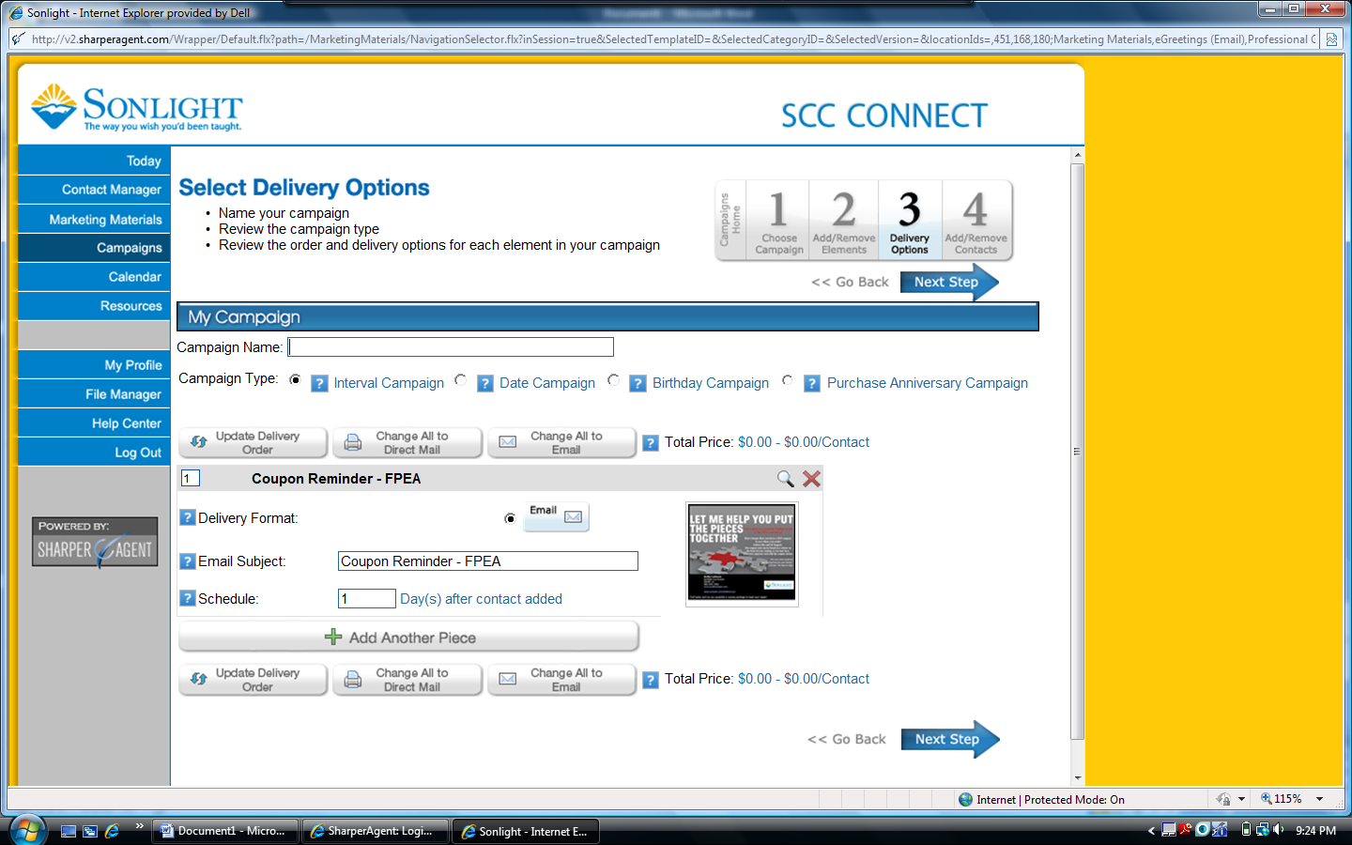

The next screen is where you will designate who will receive this marketing piece in your campaign. Following the example that I have provided, I was sending this piece to all of my contacts from the FPEA convention. I had already followed the instructions provided in the first training webinar and document to upload the contacts from my prospect spreadsheet and connect them to the FPEA group so that they are in my SCC Connect system to use in campaigns.

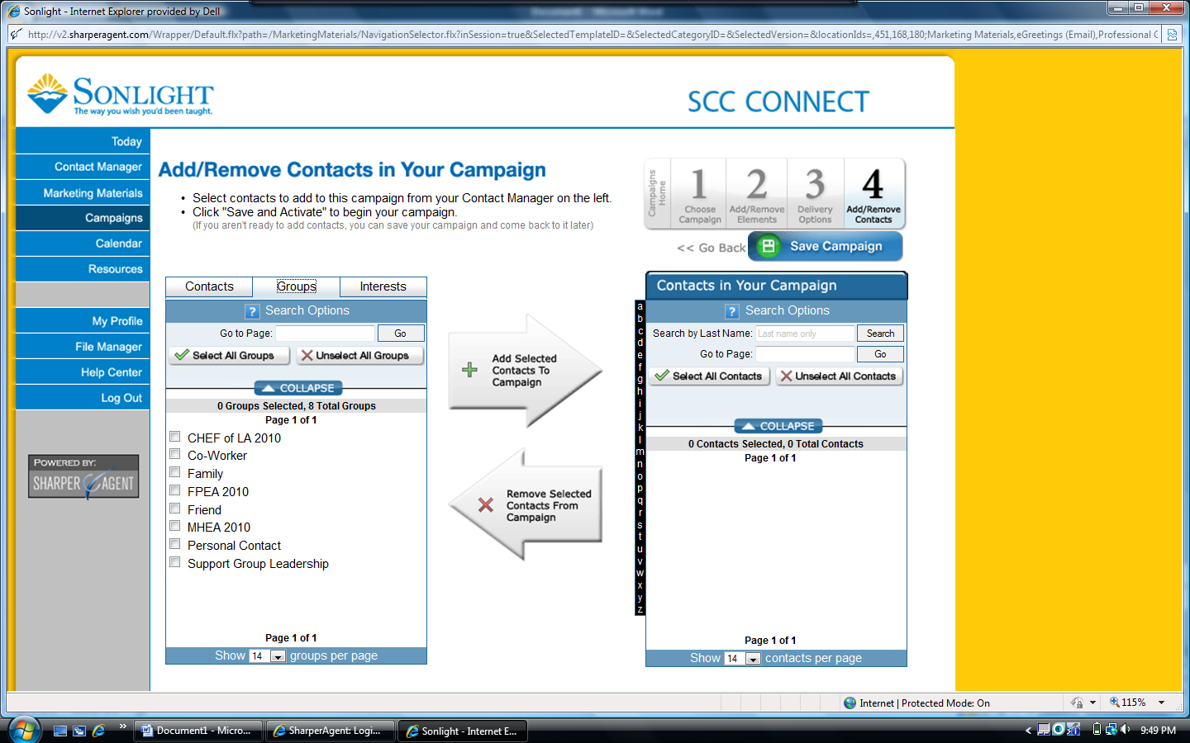

In the left box, click on groups then click on the box beside the group you want to use. In other situations, you could work from individual contacts listing, adding them to your campaign contacts for more specific mailings.

After the recipients have been selected, click on the “Add Selected Contacts to Campaign.” A new window will appear that shows the verification of the contacts for the campaign. It also indicates the costs related to the campaign, which will be “0” unless you choose to do a print mailing. Under the Contact Verification header you will find the number of valid and invalid contacts – invalid contacts are usually those that did not have an e-mail address provided on your original prospect list, or those who have opted out of any prior e-mails and are now tagged in the SCC Connect system to not receive future e-mails. Click the box indicating that you have previewed the elements, then click the “Add Contacts to Campaign” button. [Note: When I have set up my campaigns, I get an error message, but clicking OK clears it and puts the contacts in the box on the right.] Click the “Save Campaign” button.

Once you have set up your campaign(s), you should see them listed in a menu when you click on “Campaign” from your SCC Connect home page. You can see the campaigns that I have set up, along with the scheduled delivery dates and status, and the number of contacts reached.

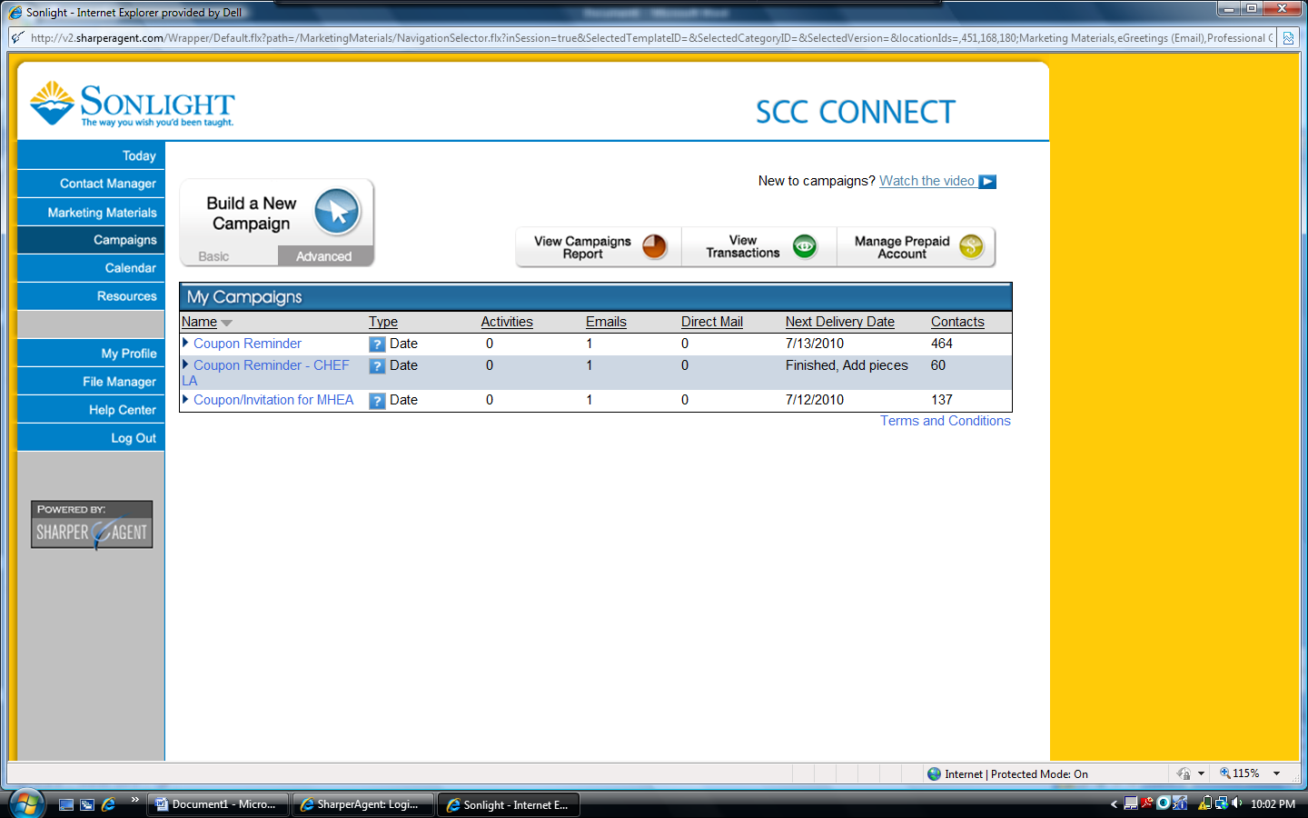

Once a campaign has run, you will receive a recap e-mail from Sharper Agent telling you how many e-mails were sent and how many of these bounced back (due to incorrect address), or resulted in an unsubscribe request or a spam complaint. The SCC Connect system is designed to send the e-mails individually so that it should not result in a spam appearance; however, in the 3 campaigns that I have now run, I did have one spam complaint reported.