**SCC CONNECT – Managing Groups**

Consider these options when setting up your groups

* Type of lead they represent (from convention, workshop or referral)
* Most relevant demographic profile (how do you want to track the customer in the future – the state they live in, the event they attended, etc.)
* Interest groups for specialized communication (perhaps based on what they purchased – a notation for preschoolers, high schoolers, foreign language students, etc.)

The **Manage Groups** button above the window allows you to create new groups or interest areas which you would use to tag and differentiate your contacts

* Groups allow you to identify contacts in sets (i.e. convention they attended, when they last purchased, etc.)
* Interest groups can further delineate contacts (such as having PreK, Elementary or High School students, using particular Core levels, new Sonlighter – these can be tagged based on data in your monthly Sales Report)
* Group designations can be assigned when importing contacts
* Additional designations can be added individually, perhaps based on sales reports

**Putting Existing Contacts into a Group**

*This process would apply if you find that your contacts did not get uploaded into a Group in your SCC Connect system or if you are working from your Sales Reports or Commission Reports and wish to designate customers as current purchasers.*

First of all, go to that file that you used to upload to SCC Connect. Make sure that the contact information on this page is sorted alphabetically, and then print this page for reference while you work in SCC Connect (saves bouncing back and forth from one screen to another). You only need the first few columns of the information, primarily name and street address.

Once you have your reference sheet printed, log in to SCC Connect and click on Contact Manager. You will see the basic screen with customer names in the left column, and a gray column on the right.

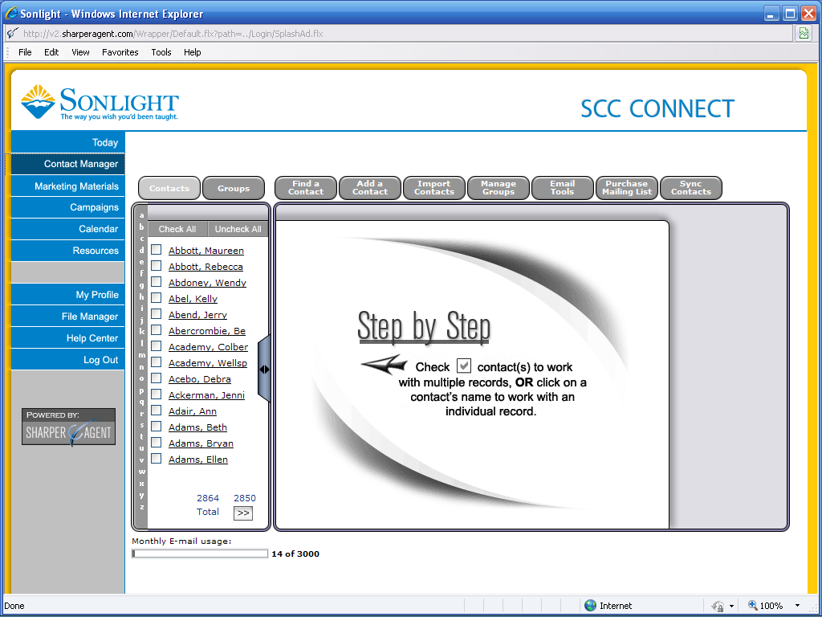

Using your reference sheet, look for the first name in your SCC Connect contact listing. If you don’t find the person on this first display, click the “>>” next to “Total” at the bottom of the left column to advance to the next set of names. As you locate each name on your reference list, click the box next to their name to put a check mark in the box.

If your reference list has names that skip letters of the alphabet, you can quickly skip forward in your contact listing by clicking on the appropriate letter in the dark gray vertical column next to the contact listing names. This will advance you to the beginning of that letter in your alphabetical listing.

If you have a large number of contacts in your system, you can use the “Find a Contact” tool by clicking the grey button at the top of your window, then click on the top search option to search by contact info. On the search screen you can type in the first few letters of the last name and scroll down the page to click on “Search.”

When you click the box next to the last name on your reference list, look over into the gray column on the right of the screen. Toward the bottom of the action list in that column you will click on “Add to Group.” If you are adding several contacts to the same group, you can mark them all (clicking the box next to their name) and after marking the last one select “Add to Group” to speed the process.

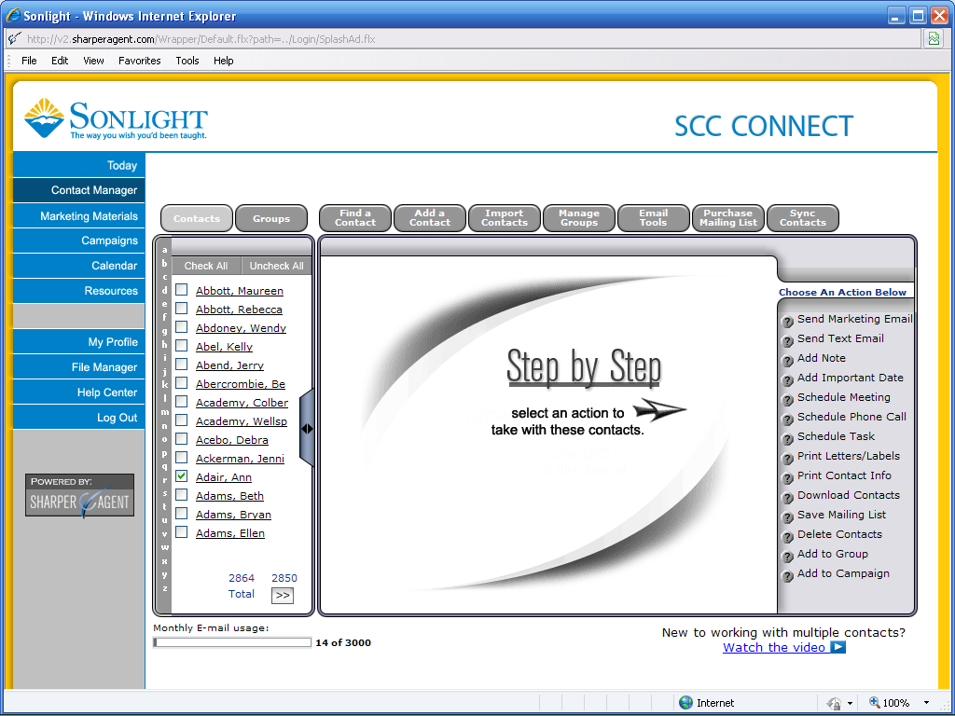

The next screen you see will give you the list of the Groups you have entered into the system. Select the Group to which you want to add the marked contacts and click “ADD.” Go back to check a couple of the contacts from your list to ensure that the Group was added to their record.

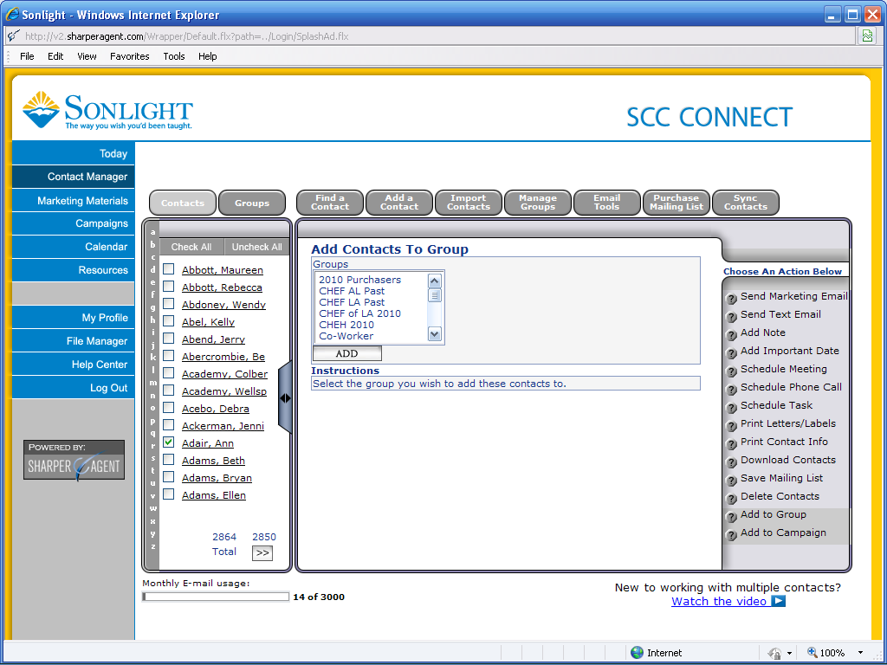

Updated 9/24/2011