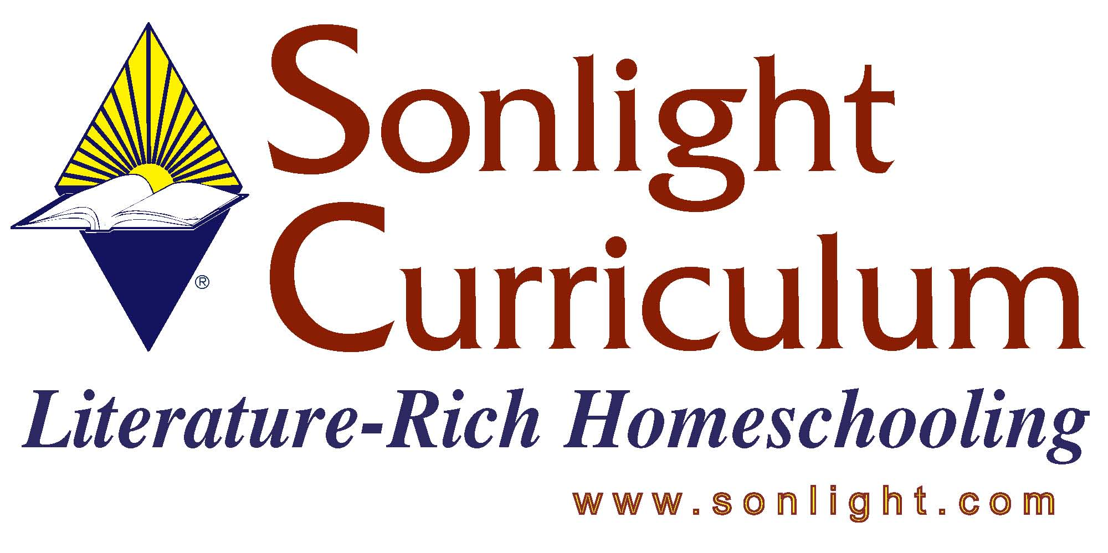
Please feel free to email me again if I can be of further assistance. Thank you for the opportunity to assist you today!
Blessings,
Judy Wnuk
Customer Champion
TITLE: Real Science 4 Kids – Level 1
Presenter – Judy Wnuk

PRODUCT AUTHOR OR PUBLISHER:
PRICE: $

APPROPRIATE AGE RANGE OR READING LEVEL: approx. 3rd grade

What is included in this product? Hard, glossy cover book

Give a 4-5 sentence description (or bullet points) of the goals or concepts this product teaches …

This over-sized book contains 66 pages plus an index. The gloss-finish pages include many colored illustrations.

Ten chapters include:
- Life science – taxonomy/classification
- Cells – structure, eukaryotic/prokaryotic, plant/animal, description of organelles
- Photosynthesis – basic description, chloroplasts
- Parts of a plant – includes roots/stems/flowers
- Plant growth – covers flower/fruit/seed, plant nutrition and life cycle
- Protists I – basic instruction on the microscope, movement of protists
- Protists II – nutrition, euglena/paramecia/amoebas
- Frog life cycle
- Butterfly life cycle
- Ecosystems – food/air/water cycle

This is a colorful, thorough introduction to biology. Illustrations will capture a student’s attention. Brief amounts of text will keep kids from getting bored.

2008 FAQ

