Select the options button 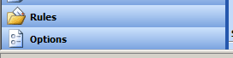
In the options menu select I’m currently out of the office. Type the message you want the sender to receive in the input box and click save.
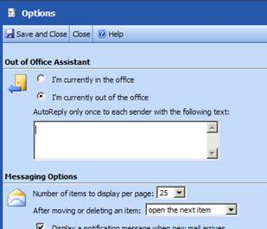
I tested this function and it does work. You will still receive messages but the sender will also receive your away message. If you want to test it you can send an email from you home account.

