Talking Points of MFW K Basic Package:

- Are you looking for a program that requires little prep work or do you want one that requires frequent library trips, research and prep work such as looking for articles on specific subjects and cutting out related pictures?

- Are you looking for a literature based program that gives your child a well rounded education while providing comprehension questions and answers, integrated critical thinking and cultural literacy questions and answers, vocabulary development information and other resources or would your rather do your own research and come up with appropriate questions, answers and background information?

- Are you looking for a complete curriculum that has all the books and teaching materials included, or do you want to collect all the necessary resources yourself?

- Are you looking for an easy to use instructor guide that is laid out with weekly plans and the option of a 4 day or 5 day schedule?

- Are you looking for daily scheduled read-aloud time where you can snuggle with your younger kids and connect with your older children in a meaningful way?

- Do you want to educate your children to be ambassadors for Christ? Do you want to raise children who can engage with their culture and converse with people of different faiths, nationalities and backgrounds with intelligence and empathy while being secure in what they believe?

- Do you want to inspire your children to love to learn and to do creative projects because of that inspiration, or would you rather have pre-planned activities that require time and prep work from the parent?

- Are you looking for an academically strong program that will prepare your children for college, career or whatever God calls them to do?

Overview of MFW K Basic Package:

My first impression was that the box was very small, rather pathetic. The box that contained the whole K Basic Package was 9x12x 2 inches high. They had quick delivery, shipping the day after I ordered. The teacher portion is small and spiral bound, so it is difficult to have any flexibility in organizing or using it. It is a total of 12 pages. It was hard to get excited. I tried to think how I would have responded when I first started homeschooling and I think I would have thought it seemed rather dull.

The 143 student pages are activity sheets for learning the alphabet, leading to easy reading worksheets. There are no student books to read. The reading ends about where SL’s LA K does, with sentences such as, “Ten men had a hen.” They are shrink-wrapped pages and do not have any punched holes so I am not sure how you are supposed to store them so they don’t get lost. They look much like SL’s LA activity sheets. The nice thing is that the handwriting is integrated, with instructions, so that when you teaching the letter S, for example, you work on the “S” sound and writing that letter. Many people complain that with SL the handwriting and letter learning do not line up.

The curriculum is much like what is in our P4/5 with LA K but without nearly as many books. This is not a literature based curriculum, at least not at this level. It is more of a unit study curriculum. The math is very minimal, more like what we integrate into P4/5 with using the 100’s chart. They do have calendar skills but they are very minimal and not colorful or fun like SL’s calendar.

The Memory work at this level is called “Words to Remember” which are condensed ideas from the Bible, but not actual Bible Memory. The verses are rather random as they apply to the theme of the week; most of them feeling very contrived. You can see my outline in section VIII for specific examples.

There is no history and a very minimal amount of geography. No study of peoples or places. This actually reminds me very much of Bill Gothard’s Animal Studies books on character studies. The whole basis of this program is an animal every unit and then study the letter associated with that animal. No information about the animal is given; the parent is to find all the information. It almost had the feeling of a resource to teach the parent how to do a unit study, but like it isn’t really a complete unit study. There is a lot of research and prep-work a parent needs to do to get ready to teach a unit.

I found the layout frustrating and VERY repetitive and boring. It is spiral bound so not very conducive to re-organizing. They did the same basic format for every single 6 day unit. Even all the activity sheets have the exact same format, using the same templates. For the new homeschooler this might feel very comfortable and give them confidence. But, I would think the kids would get bored with the exact same activities for learning to read and learning about different animals. Every single letter is learned the very same way and in fact they give you the directions once and then you just do the same thing, over and over and over again using different letters but the same activities. The activity sheets look the same almost every week, just using different letters.

I found the “hands on” activities to include a lot of parent prepared materials and a lot of “Have your child draw or paint a picture.” They also want the parent to set up 27 file folders and the parent is supposed to label each folder with the unit topic, like “Octopus.” Then they are supposed to find articles, pictures and so forth to populate these folders. Lots of prep work, but necessary if you are going to study one animal for 6 days. They give you little to no information about the animal, but tell you to get a book or go to the library and look in an encyclopedia. See section 8 for specific examples.

I did think they gave quite a few suggestions on how to add narration type activities and encouraging nature walks and outdoor play time. This is more of a Charlotte Mason approach, but I think it is helpful to tell parents on a regular basis how to encourage their child to “narrate” back or act out what they have learned and to tell them that outdoor play is important.

The one nice feature they had is a set of alphabet flash cards which are colorful, slick and about 8”x5” in size. Each unit uses one of these cards, for example A has an apple, H has a horse, etc. They suggest a few games you can do with these cards such as memory games, tracing the picture for art, talking about the animal for science, sorting the cards in various ways and so forth.

They describe their program in their promotional materials more fully than SL does. For example they include things like “Good for different learning styles, challenges strong learners and nurtures slow learners, phonics, children’s lit, character emphasis, nature study, etc.” Sonlight should add more things to the core descriptions, along with cultural literacy and critical thinking. I think this is one area where SL under promises and over delivers and should really feature every area SL teaches. Many people do not realize all that our Cores include.

My Father's World Outline
K Basic Package--Gives child a strong Phonics Foundation

I. First Impression
A. Small
Box
9x12x2
B. Quick Delivery
Ordered 1-13
Shipped 1-14
Received 1-18
C. Looks Pathetic, not much there for a K student
D. This program is NOT literature based as they advertise, but is a unit study approach
E. Most hands-on activities are comparable to the activities in SL’s P4/5
II. A Complete Kindergarten Curriculum 122 pages
A. Pros:
- *Biblical Foundation
- *Thematic Units that integrate all subjects
- *Phonics
- *Children's Lit
- *Good for different Learning Styles
- *Challenges strong Learners and Nurtures slow learners
- *Clear instructions
- *Lessons 60-90 minutes long
- *Organizational Directions for keeping cards in order, etc.
- *Has a nice chart of what you need to add
- *Has notes for classroom teachers
- *When you study a letter, you learn to write that same letter at the same time,
- *Directions for Reading the same every single week, not reprinted, once you know what to do you don't have to read directions again.

1. Note: SL should put more topics to say what is covered, such as Character Emphasis, Cultural Literacy, Nature Study, etc.

B. Cons:
- *NO books
- *Units are not laid out to be done in a week, no logical overview
- *need to set up 27 file folders and find articles and pictures to go in them
- *Frequent trips to library
- *Use one book on sixth day of each unit
- Lots of flipping back and forth, no chart overview
- Directions for Reading is used over and over, not separate for each unit, you do the same EXACT thing every single unit, just using different letters, BORING
C. Need to Add:
1. Bible, NIV preferred
2. Textured alphabet letters, like a Laurie Puzzle
3. 27 file folders, student pages are not 3 hole-punched
4. Pictures and articles, nature magazines, etc. that will help you teach each unit.-Put in folders as you find them
5. Basic Supplies like pencils, crayons, clay, paper, etc. –Similar to SL’s P4/5
6. Children's books; encyclopedia
a. Suggest 3-4 books for each unit. Also supposed to look for non-fiction books about topic, no suggestions
b. Example:
Unit 2 about the moon -Goodnight Moon
Unit 10 For water; Make way for Ducklings
Unit 12, Goat, A Year at Maple Hill Farm
7. Recommend: Ant Farm and Butterfly kit
8. Music: Add Intro to Classical Music, CD with MFW activity sheet
D. Daily Routine

1. 100 Chart, calendar
a. Like SL Create a Calendar, but not as nice
2. Teach Reading Skills
a. Like SL K LA
3. Daily Special Activity
a. Science, Math, Bible, Art, Children's lit, creative thinking
(1) Parent needs to find and gather factual info about each topic, they recommend frequent trips to the library
(2) Parent makes a badge-a-unit [26 total] in shape of theme with words to remember
(3) I suggested story book per 6 day unit
(4) Nice suggestion about how to do narration by telling back, or acting out story, draw a picture, making "books" to retell story
(a) Note SL could incorporate this idea, giving people ideas of more active things a child could do to show his understanding of the material.

I heard one mom say she has her child act out stories with toys.
(5) They encourage child to play outside, explore nature, etc.
III. K Student Materials
143 pages, plus cut outs and calendar and 100s chart
A. Game Cards
Handwriting chart, Short Vowel Son Card
IV. A-Z flashcards
A. Large, glossy, colorful, nice
B. Simplistic, Letters only with pictures
V. Suggestions to complete program
A. Laurie type letter puzzle
VI. Emphasizes:
A. Hands On Activities
B. Thematic Units
C. Explore God's wonderful Creation while learning Beginning Phonics/Reading, Math, Science, Bible, Art, Literature and Creative Thinking Skills
VII. Learning Activities
A. Letter of Day Suggestion, similar to SL P4/5 Letter of the week
B. Science-Select a A-Z card and talk about it for Science
C. Memory games with flash card, similar to our Teddy Bear Game in P3/4
D. Art- Pick a A-Z card and look for pictures like it in books; draw a picture on a card
E. Cards--make up story about pictures, etc. Similar to our P4/5
F. Notes: cutting, coloring and cutting
1. Creation book, cut out description of what happened that day, draw picture, staple pages together
2. Quite a bit of "have child paint a picture"
G. One science activity a day, such a dry a grape, make a sundial, use a globe and flashlight to demo day and night
H. A few activities and a question about the one library book
VIII. Bible
A. MFW has actual Bible reading, one-two verses per 6 day unit, SL no actual Bible reading in K, Bible Memory and Erg. Bible Story Book

1. The verse is pre-printed in the Teacher Guide
B. Bible seems contrived
1. Lesson 23 Fox
"Your commands made me wiser than my enemies, for they are ever with me."
a. Explain that Foxes are sneaky and tricky; he pretends to be a friend but is an enemy. He is lying, God never lies.
b. Badge with words to remember:
"God's word makes me wiser than my enemies"
(1) Note: Student is not memorizing scripture, but MFW words to remember
(2) One activity: make a fox shaped badge--I have no idea how you would do this if you are an un-artistic as I am
c. The one book that is recommended for the Fox is "The Gingerbread Boy."

2. Lesson 18 Zebra
a. Words to Remember "I can't hide anything from God."
b. Parent draws an outline of a Zebra for student to draw stripes on
c. 2 Bible Verses:
"Nothing in all creation is hidden from God's sight. Everything is uncovered and laid bare before the eyes of him to whom we must give an account."
d. Make a Zebra Shaped badge with words to remember
e. Find Africa on a map.
f. The one book for this week is: If I Ran the Zoo--there are a few other suggestions if you can't find this book
3. The Octopus Lesson 9
a. Memory: Even the octopus praises the Lord
1. Parents make an octopus shaped badge with these "Words to Remember on them" [I have no idea how a artistically challenged mom like me would do this"
b. Bible Reading, three verses for the unit, preprinted.
1. "Let Heaven and Earth praise Him, the seas and all that move in them"
c. Draw or paint an ocean mural
d. Give students a black and white outline map of the world [no indication of where you would find this] and have child color seas/oceans
e. Literature portion: A House for Hermit Crab or Swimmy
4. The Horse Lesson 14
a. Memory: "I obey right away"
1. Parents make a horse shaped badge with the words to remember.
b. Bible Reading, two verses for the unit, preprinted
c. One is from Colossians about "Children obey your parents in everything, for this pleases the Lord."
d. Talk about Noah and his sons. They were probably very obedient sons, because they worked hard for a long time helping their father build a very big boat. {No scripture to back this up}
e. "Then he [Jesus] went down to Nazareth with them [his parents] and was obedient to them"
1. Tell children when they see a horse picture they should think of a well trained horse and then remember they are supposed to be obedient
f. Art-Make a horse out of clay by looking at a small plastic horse or a picture of a horse
g. Tell Story of Jonah, about not obeying right away
h. Read the book "Baby Animals"
IX. Language Arts
A. ABC chart included, 2 letters per day
B. Alphabet games and Bingo included, much like SL LA K
C. Nice Alphabet cards, colorful and oversized
X. Music- Words to songs are included

Topic | Sonlight | My Father’s World | Quotes | Quote Source
Literature Based Curriculum | Sonlight is literature based, in that most subjects are tied to real, living books--reading, history, math, geography, writing, science, art and music appreciation, critical thinking, seasons, etc. | MFW bills itself as literature based, but in the program I reviewed it is not really literature based. It is more of a unit study that the parents does a lot of research for, the child colors and cuts out related items. The actual real living books used with the children are minimal compared with Sonlight.
Schedules | SL has a nice weekly schedule, very easy to see what is scheduled for the week. It is easy to use as a record of what has been done and easy to adjust. Page numbers are easy to find so you don't have to figure out how much to read on a daily basis. SL has great parent resources, questions and answers. The IG is unparalleled. | There is not a compiled, easy to read weekly schedule or chart. The directions are imbedded in the weekly notes. Not easy to see how much to accomplish, not a good overview, not an easy way to keep records. Not many notes or back-ground information given. | With SL, I can just look at the five/four day schedule and know what is going on. With MFW, so many times the weekly schedule says "see the teacher notes" which means I have to look at the teacher notes to see what we will be doing. This can be very frustrating because I like to see a scheduled laid out for the week to know any adjustments that we need to make because of appointments and I write the date of when we do the reading/activity on the schedule page. | https://www.sonlight-forums.com/showthread.php?p=2114747#poststop
Materials | Sonlight provides all the books and background information you need. The extensive notes, comprehension, literacy, nature questions, etc. give the teacher maximum information with minimum effort | MFW does not contain most of the literature. There is a recommended list from which you can choose. Some books have a question or two about them, but they recommend that the parent visits the library often, does their own research about every topic, cut out articles and pictures and so forth and make 27 folders with this information in it so you can present it to your children. | The SL program is a complete ready to go program. While the MFW you have to find your own readers for your children. They provide a list in the back of the teacher manual for book titles and video titles. ---The other things is SL is a full program that you don't need a book basket or anything else, just open the box and you're ready to go. | https://www.sonlight-forums.com/showthread.php?p=2114747#poststop-----https://www.sonlight-forums.com/showthread.php?p=1959060#poststop
Level | Sonlight's curriculum has more substance and is written more intellectually. SL is a strong liberal arts based academic education. | MFW K program is a lot like Sonlight's P4/5 with K language arts. It seems lighter and at a lower level than SL. | 5. MFW seems to be lighter on the amount of work which is why I choose to use it this year as the main program. Our son is using his level readers from SL and I read the SL books aloud to him and we do bunny trails with the SL activities. | https://www.sonlight-forums.com/showthread.php?p=2114747#poststop-Chariot
Format | Sonlight's format is easy to manipulate. Because of the 3 hole punched IG's and student pages, it is easy to adapt it to various teaching styles. | MFW Teacher's guide is spiral bound and the student pages are not hole punched. They would be hard to organize unless a person punched them themselves or organized them some other way. | Minor issue but the SL is three-ring binder which means I can take out only what I need for the week or next couple of weeks while the MFW is spiral bound. | https://www.sonlight-forums.com/showthread.php?p=2114747#poststop-Chariot
Activities | SL does not promote that it incorporates hands-on ideas. We say that if children are inspired by good literature, they will create their own hands-on projects. Many parents feel their children need scheduled activities. We have them in P3/4 and P4/5. Core 5, younger LA, Grammar and in all the science. This should be more actively promoted as "Twaddle-free activities." [Another idea might be to make SOTW activity books or Hands and Hearts History kits available through Sonlight they have everything you need for activities and notebooking.] | MFW incorporates many more hands on activities and advertises the curriculum as such. I found many of the activities in the K program to be much like what SL has in the P3/4 and P4/5 program. There was also a lot of twaddle and a lot of parent prepared activities. | I would like some activity ideas. I think my group of learners needs it, but I have a hard time finding them on my own. And I don't want a bunch, just maybe one or 2 a week.------My kids thrive with multi-sensory learning, and that is what MFW specializes in. | https://www.sonlight-forums.com/showthread.php?p=2114792#poststop ----- https://www.sonlight-forums.com/showthread.php?p=2114885#poststop
Price | Sonlight seems expensive to many, but for what you get it is very reasonable. We need to focus on complete curriculum, saves you time and money, no last minute trips to the library or store, SL has it all. | MFW looks cheaper, but the K guide was $98 and all it had was a think IG with a lot of ideas of activities to do, but not much of the work was done, a bunch of LA pages and one set of colorful Alphabet cards. That is it. No questions and answers, no maps or charts, no nature questions or vocabulary work. The included math is less than what the Three R's has in it. They include a 8 1/2 x 11 100's chart and the same size calendar pages with no pictures, etc. There are NO books. | The price!----As far as price, I find if I buy books with MFW it comes out to be about the same as a SL core - so I don't think price is really an issue. | https://www.sonlight-forums.com/showthread.php?p=2114792#poststop https://www.sonlight-forums.com/showthread.php?p=2123383#poststop
Integration | Sonlight has subjects separated. History/Literature/Readers/Writing are integrated with each other, but other subjects are not. | MFW has a more integrated curriculum, with art appreciation, music appreciation, Bible and history all being integrated. This is a unit study approach. | I love how composer study and art are scheduled and included. I love the nature study aspect also, my kids are going to flip for the bird feeder and birds study. The only drawback for us has been the Bible activities, we skip most, and I would prefer the Bible not integrated into everything else, more like SL and WP. The integration is a big plus to many though.----I think MFW is well-rounded because it has art, music, nature study, notebooking, and so on, built in to the program. It has so many different ways of approaching the material. That can all be added to SL, it's just overwhelming to do it on your own sometimes. | https://www.sonlight-forums.com/showthread.php?p=2116197#poststop https://www.sonlight-forums.com/showthread.php?p=2122811#poststop
Repetition-Pros and Cons | Sonlight's LA materials have a lot of variety. The child plays different games and does different activities. The parent needs to read the directions every day/week to see what to do. | MFW does the same exact thing every single week. In fact they just give you the directions at the beginning of the year and then tell you to just do the same thing every week using the next worksheets and the proper letter of the week.
Ambassadors | Sonlight's materials confront difficult subjects and give children a heart for the world. At the K level SL students learn about homelessness and missionaries and much more. | MFW students study a letter and an animal each work. There is little geography, little learning about other people, and little learning about the world at all. | we are very strong Christians, very founded in our beliefs. And as strange as this may sound, we have decided we don't want a "bible based curric." We want a curric. that may introduce topics that are challenging - but then we can discuss them in light of our faith. Also, we love it since it is very much literature based. | https://www.sonlight-forums.com/showthread.php?p=1953258#poststop

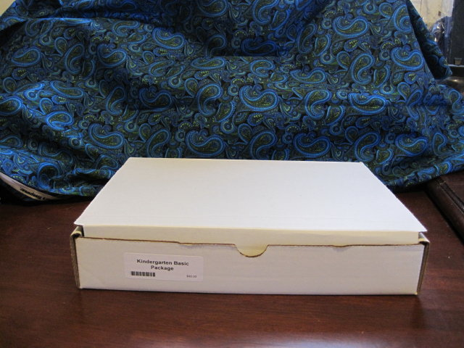The full curriculum came in this box.

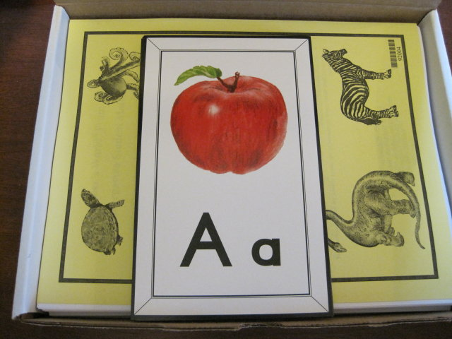 This is how it looked. You can see the large A-Z flashcard and the student pages.

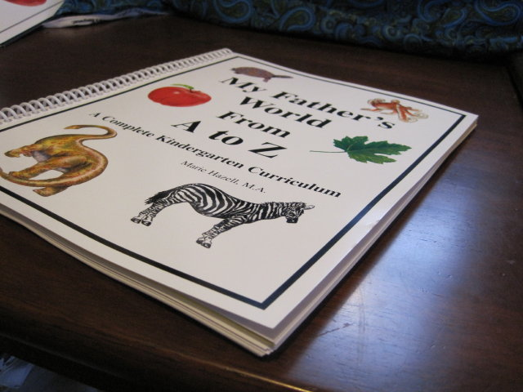This is the teacher’s guide, spiral bound, 123 pages.

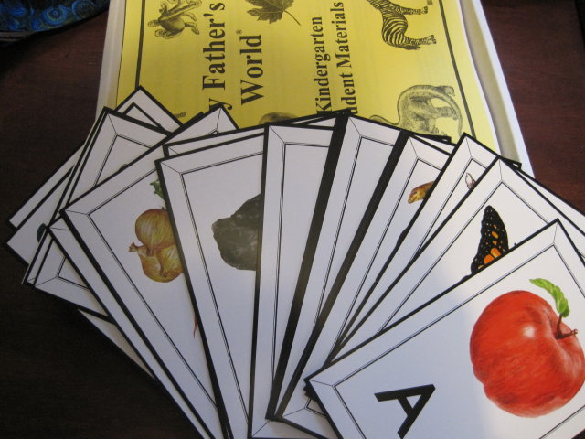 This is the flash cards spread out. They are on nice glossy cardstock, they are one sided. Each one is to be used for a 6 day unit. They are also used for a memory game, to trace over for art, as inspiration for parents to find science information about each one and so forth. On card has these ideas printed on it.
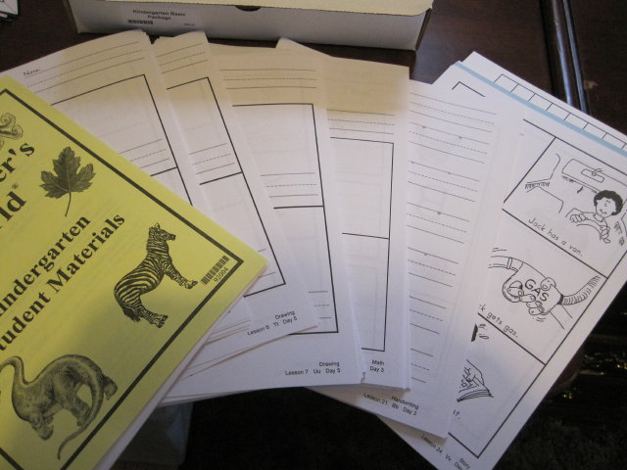
This is the what the student pages look like. They are not bound or three hole punched, just shrink-wrapped..

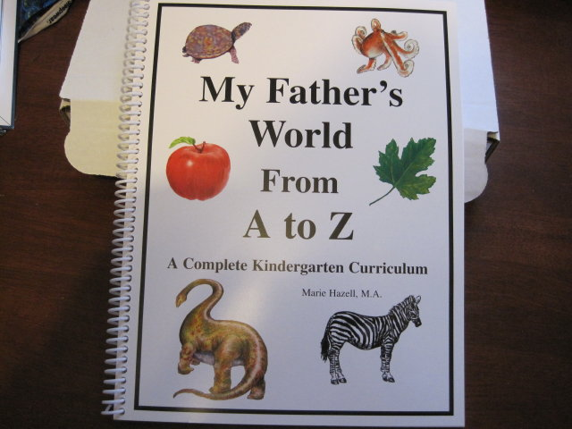
Teacher manual again.
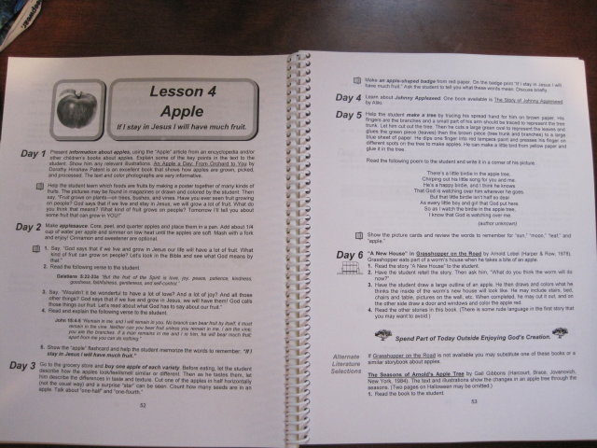
This is a copy of the lesson for unit 4. This is basically the “Core” for K, these 4 pages are to be used for 6 days of lessons. There is another portion for phonics instruction.

