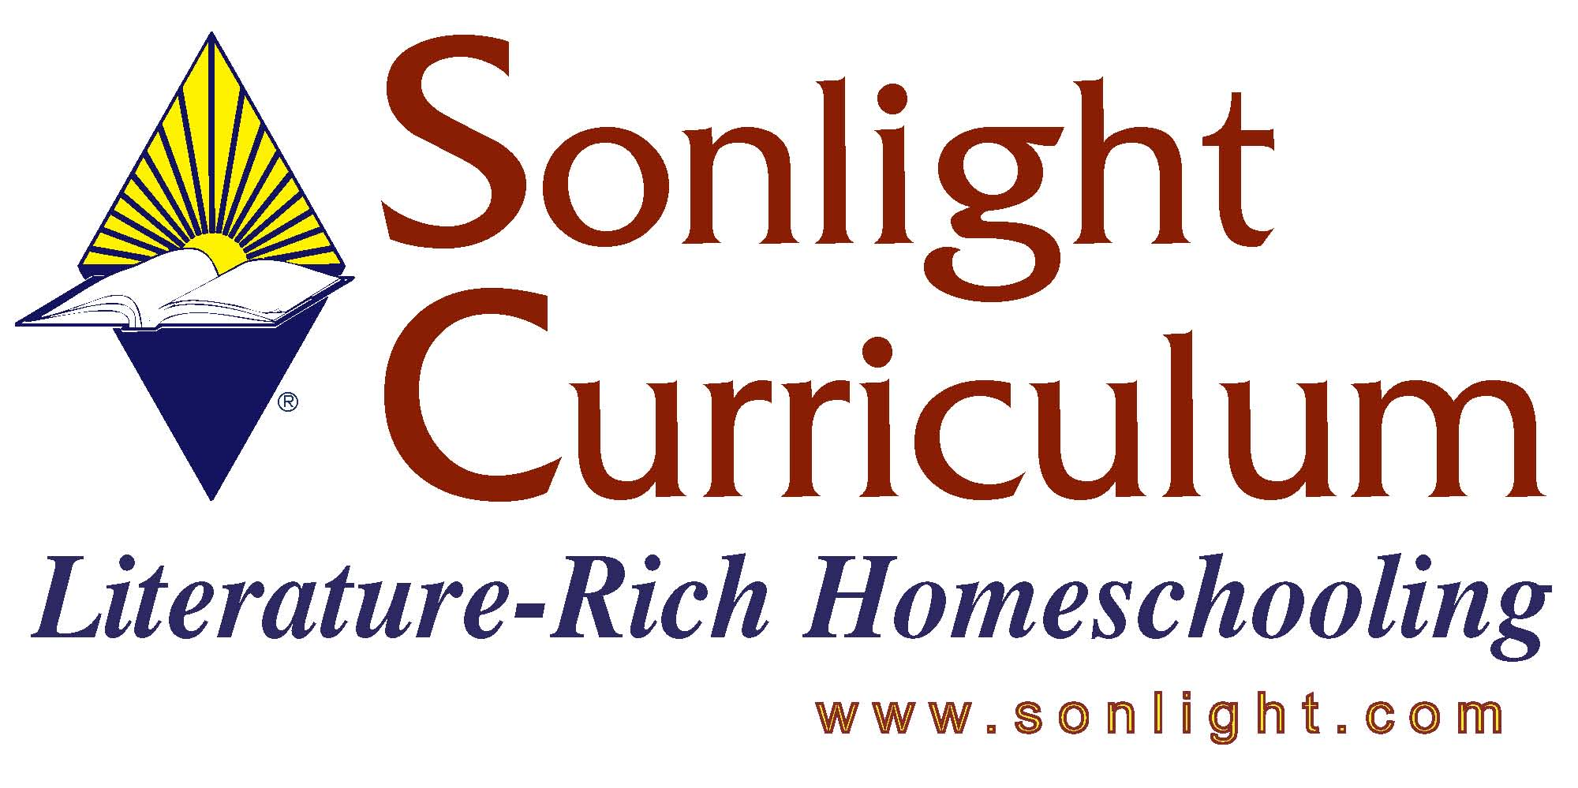

STC 2005 – Product Fact Sheet

THE ANNOTATED MONA LISA: A CRASH COURSE IN ART HISTORY
Reviewer: Rhonda Warren

PRODUCT AUTHOR OR PUBLISHER: Carol Stickland, Ph.D.; John Boswell Associates Publisher
PRICE: $22.50

APPROPRIATE AGE RANGE OR READING LEVEL:
[catalog] highly recommended for serious art students and the artistically inclined from approximately seventh grade up. My personal recommendation would be for use in high school in conjunction with world history or as a separate art appreciation or art history course.

What is included in this product?
194 pages; How to look at a painting (basic discussion of the elements of a painting), a timeline of art along with major events in world history for each of five separate time periods –
- The Birth of Art: Prehistoric Through Medieval
- The Rebirth of Art: Renaissance and Baroque
- The Nineteenth Century: Birth of the “Isms”
- The Twentieth Century: Modern Art
- The Twentieth Century and Beyond: Contemporary Art
The book includes reproductions of the majority of the ‘famous’ pieces of art throughout history and many less familiar selections, including some nudes. Includes thorough discussions of the artists, historical significance of the style and artists, elements of the piece, notes on other relevant events in history at the time, and more.

Any special requirements necessary for using/teaching this product: None

Give a 4-5 sentence description (or bullet points) of the goals or concepts this product teaches …
This selection is an excellent, thorough overview of art throughout history which does not assume any prior art education. It is a secular book with conclusions made and opinions drawn from a non-biblical worldview, but for the most part the book maintains a fairly neutral evaluation of art and its effect on and influence from history. The book is chock full of information – timelines, reproductions of original pieces of art, bullet points of information about history as shown in the art and history of the artists [similar to Usborne selections, but less busy]. Definitely an interesting read. This is an excellent addition to a world history program for high school students, or could be used as the main text for an art appreciation or art history course in high school.

How do you fit this into a school day/how do you schedule this product:
We have used this in a co-op setting as a ½ credit high school Art History course, adding in writing assignments. At a minimum I would have a high school student read through the material in conjunction with a world history course (such as core 8 and 9). This informative look at the effect of art on history and history on art cannot be missed!

THE ANNOTATED MONA LISA: A CRASH COURSE IN ART HISTORY
-Page 2-

How much parental involvement? How much student time required at each session?
If you are concerned about the potential effect of a non-biblical worldview, you will want to discuss the material with your student, but the opinions stated are typical for a secular high school history text. I haven’t found anything ‘anti’ Christian, just not a biblical worldview.

Name two or three things you feel it is important for customers to know about this product before they purchase?
This book is inappropriate for young students as there are nudes, some of them could be offensive (i.e. one example, a painting of a nude beach in recent years, mildly abstract, but full nudity is shown).
A non-biblical worldview is seen throughout the commentary.
This is the best art history selection on the market today [used by a professional Christian artist to teach an art history course at our co-op and described as “excellent, nothing else available today offers this level of information”].

