

Sonlight Curriculum Consultant

Event Expense Request Form

Please complete the expense request form at least a month prior to your scheduled event. All of your event paperwork must be turned in or your check will not be mailed. Please send to Jessica at jbrown@sonlight.com.

SCC Information
SCC Name: | Jessica Brown | Date Submitted: | 10/23/07
SCC #: | 300 | Phone: | 303-730-8193 x.123

Event Information
Event Name: | CHEC
Event ID: | TM1 | Event Date: | October 23-24,2008

\

Expenses Requested
 | Qty | Amount
Number of Workers for one day :  (Including all adults and teens) | 4 | 220
Number of additional days:  (Do not include day early set up in this figure) | 1 | 220
Day Early Set up required:  (Put Yes or NO and the total amount for allowed people) | Yes | 110
Any changes (i.e such as “only 2 assistants on Friday”) subtract the $ amount in the right column. |  | -55
Total Amount Requested: | = $ | 495

*Note: Expenses will not be paid until all assistant profiles have been turned in.

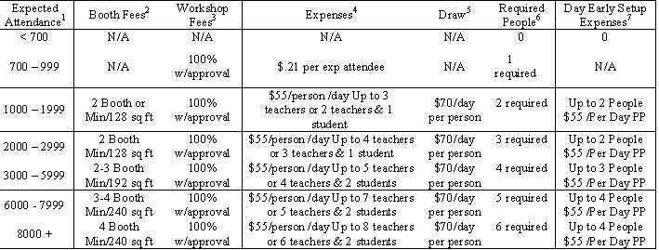

Pre-Registration REQUEST
Separate pre-registration check for 2009 |  | = $ | 100
Pay to the Order of: | Colorado Home Educators

Thank You!

