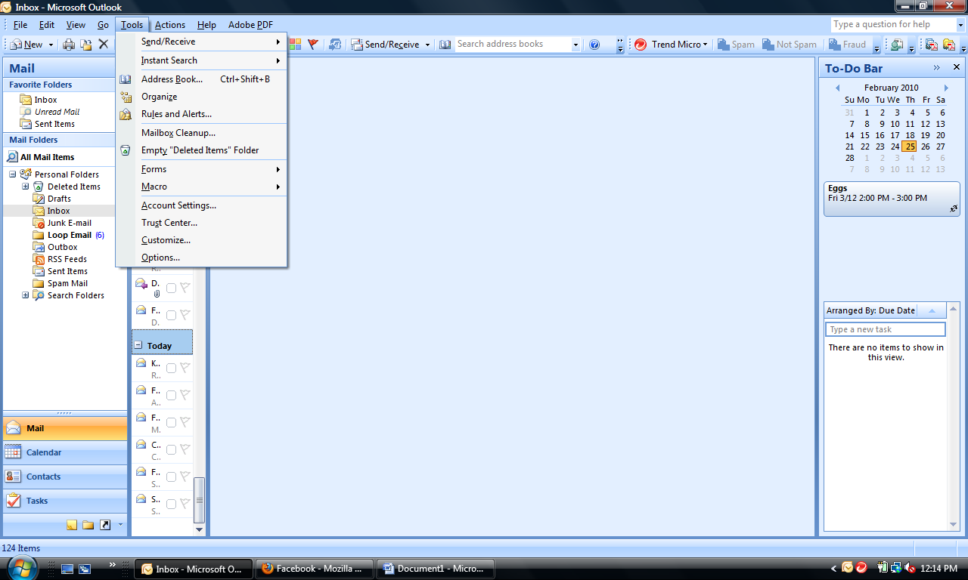

Open Outlook … click on **TOOLS** … **ACCOUNT SETTINGS …**

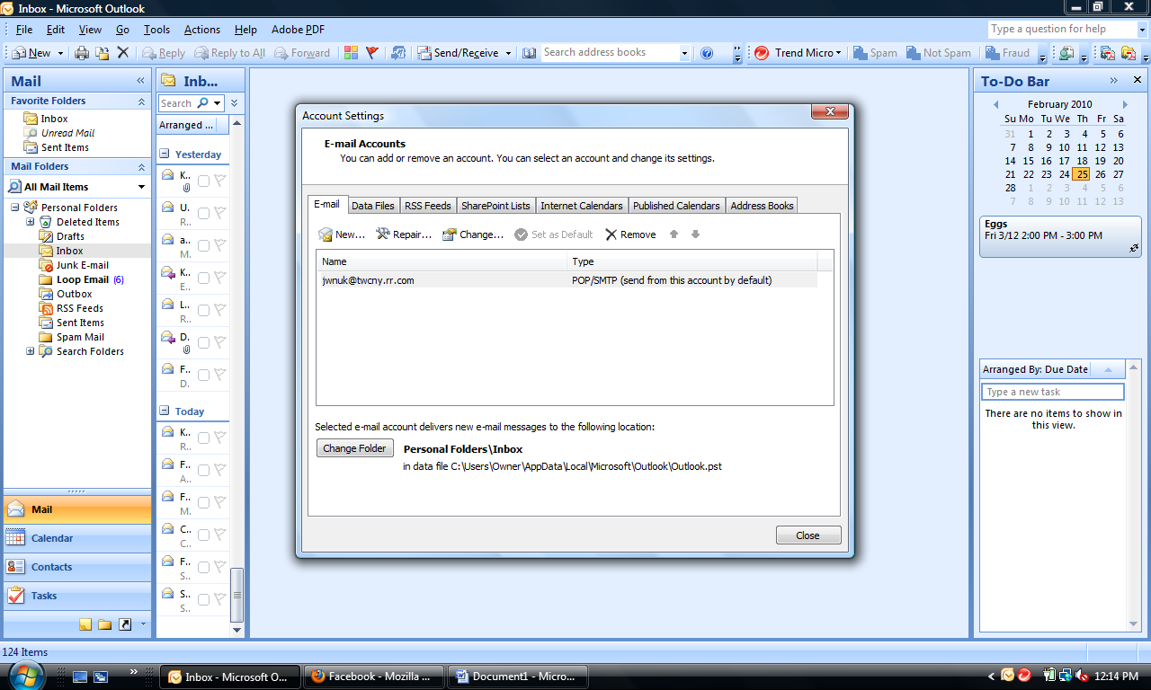

On the Email tab … click on **NEW** …

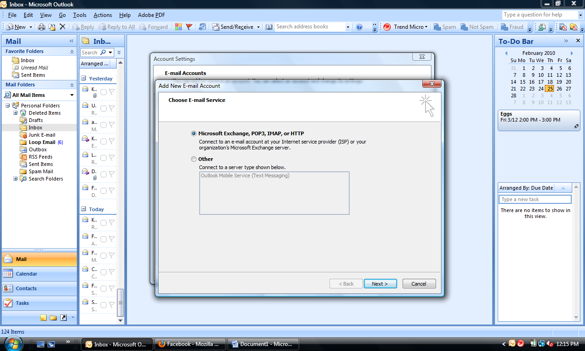

Make sure the **MICROSOFT EXCHANGE, POP3, IMAP, OR HTTP** button is checked … click **NEXT**

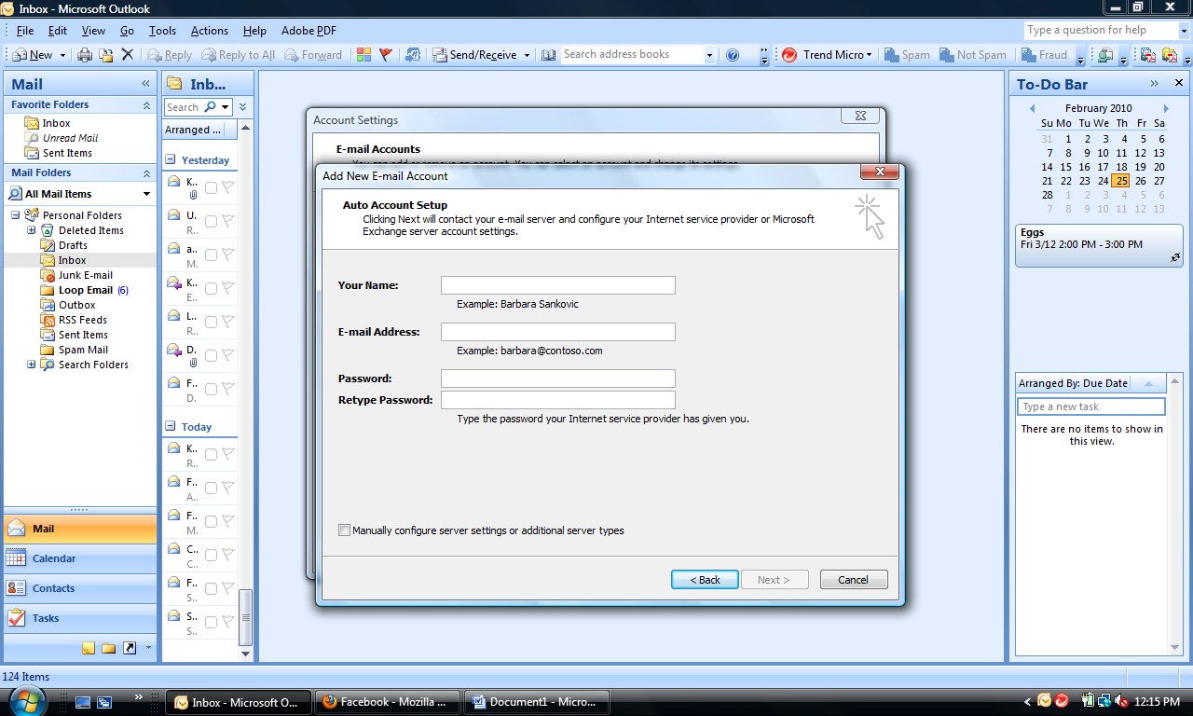

Check the box to **MANUALLY CONFIGURE** … then click **NEXT …**

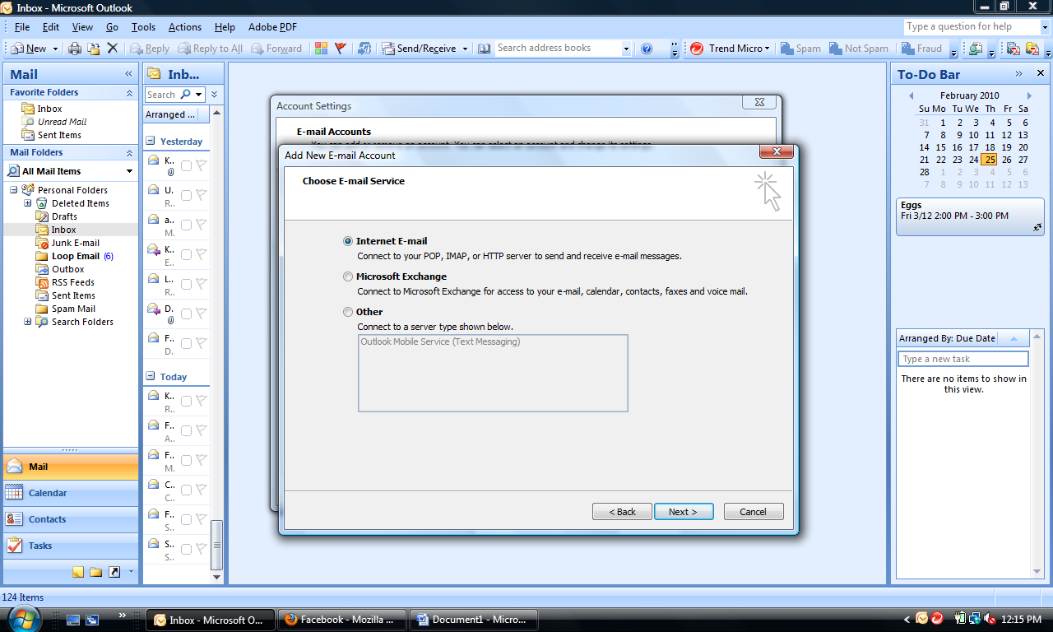

Make sure the **INTERNET EMAIL** button is checked … click **NEXT** …

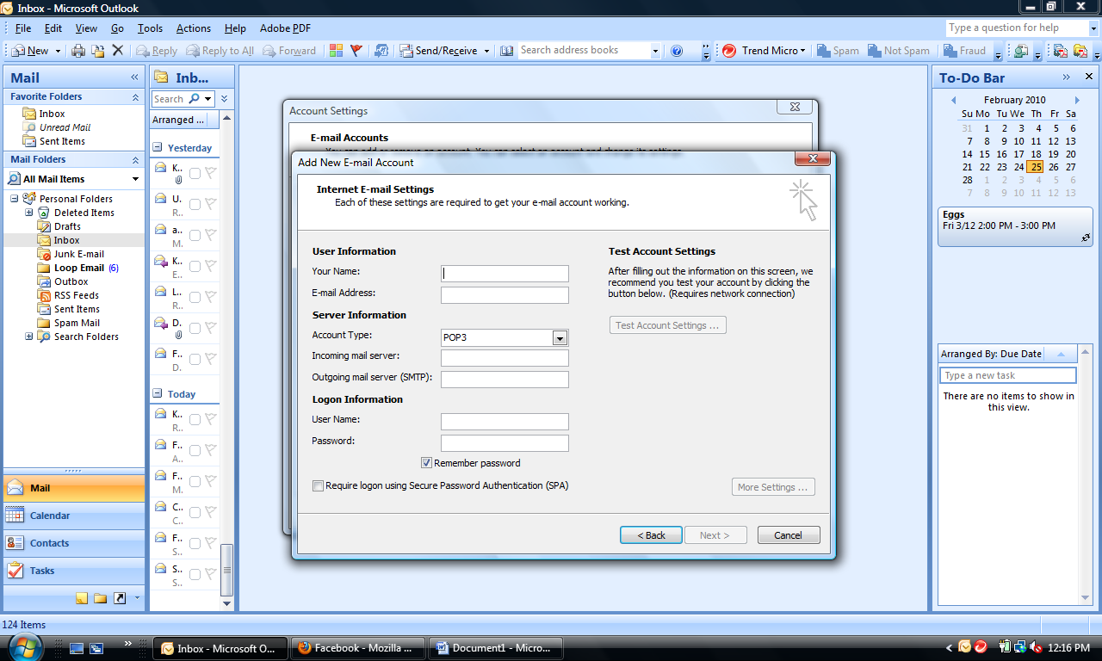

Enter the required information … be **SURE** to use your Sonlight email username and password.

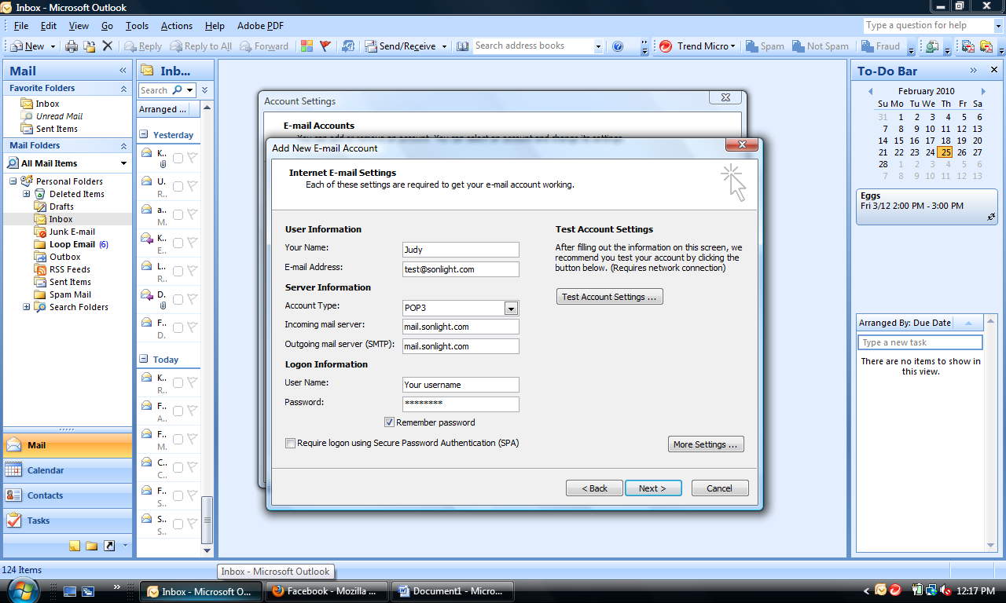

Incoming mail server: mail.sonlight.com Outgoing mail server: mail.sonlight.com …

Click **MORE SETTINGS**

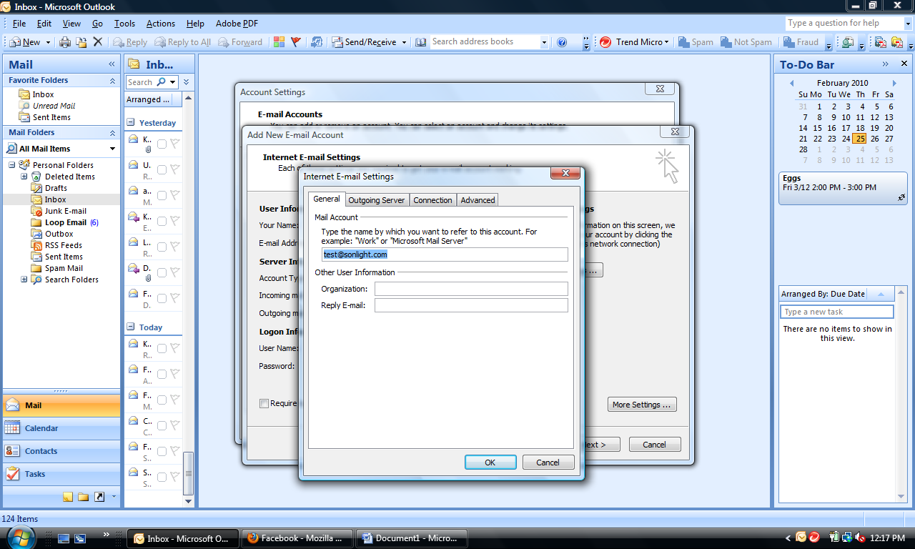

Click the **OUTGOING SERVER** tab …

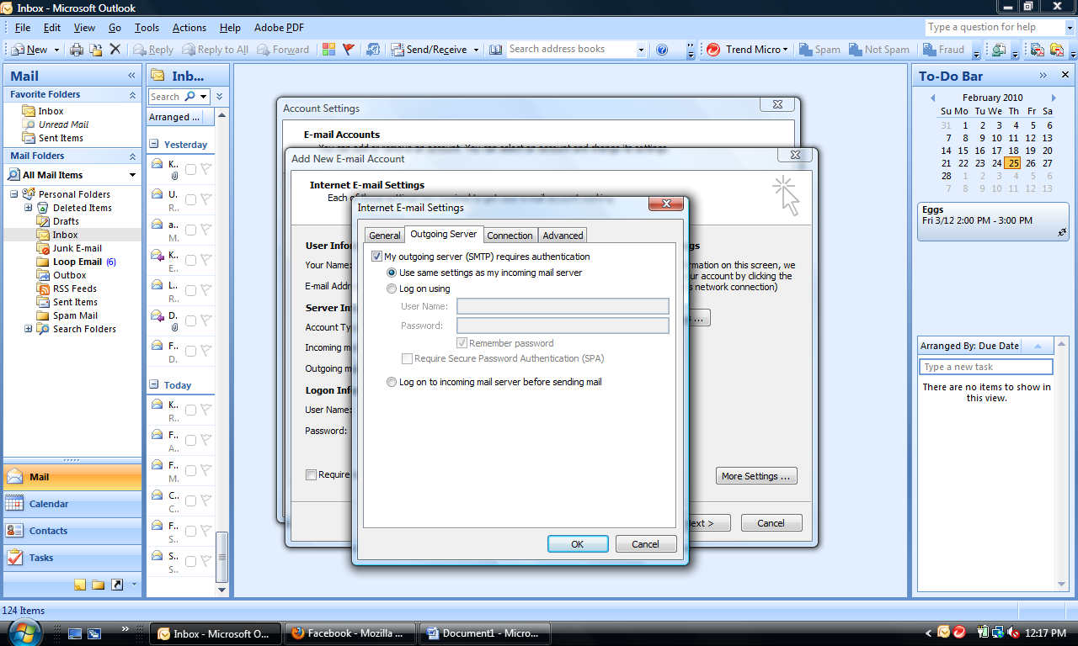

Check **MY OUTGOING SERVER REQUIRES AUTHENTICATION …** then click the **ADVANCED** tab …

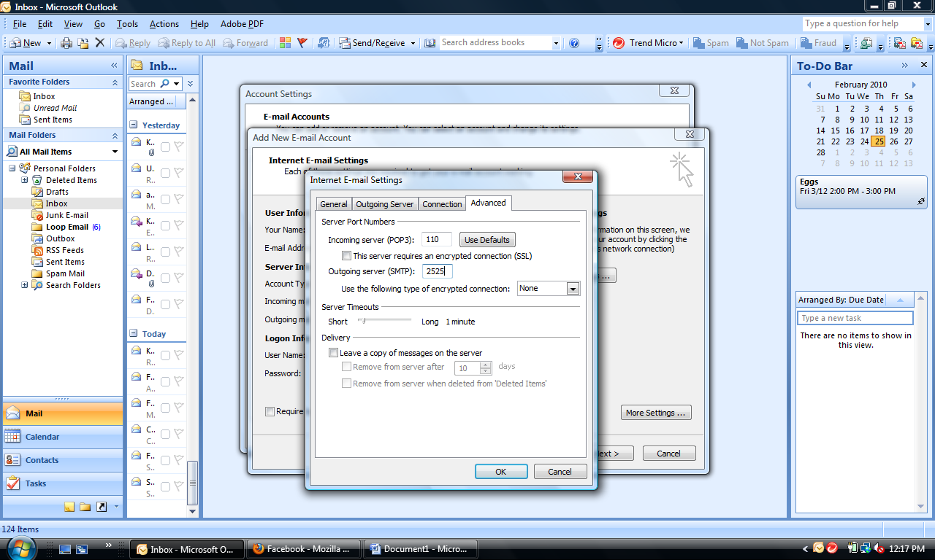

The **OUTGOING SERVER PORT** should be **2525** … then click **OK …**

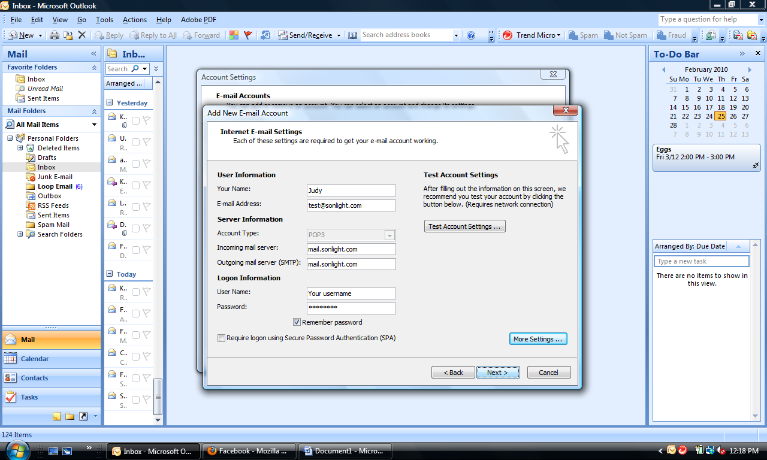

Then click **NEXT …**

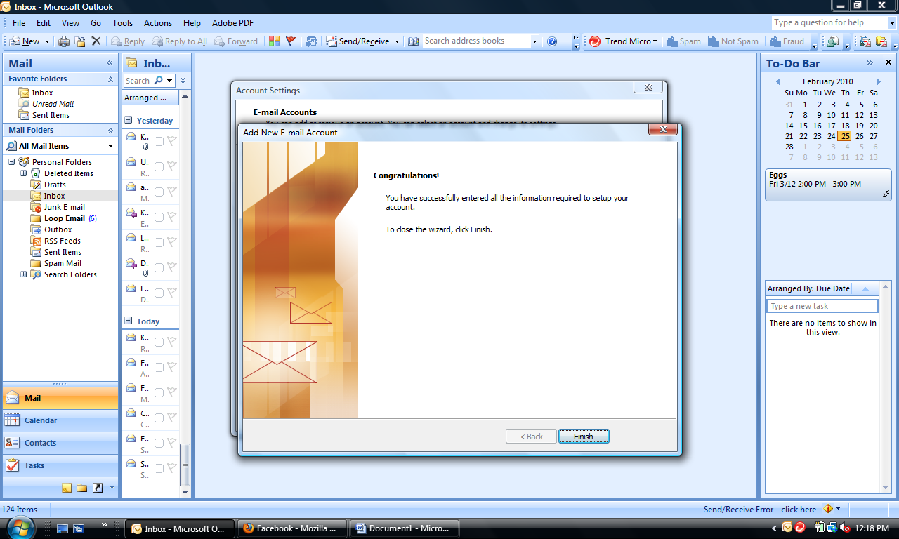

Click **FINISH …**

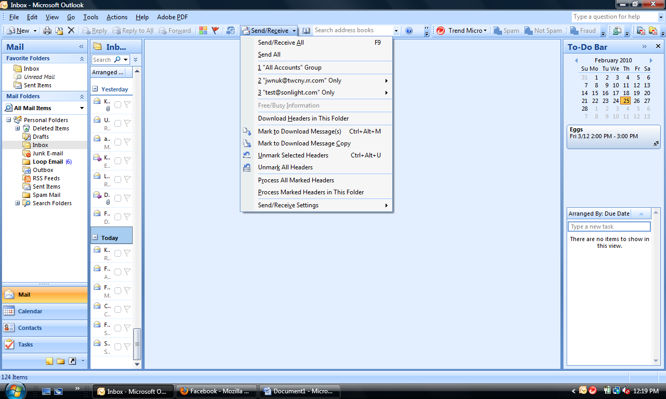

Click on **SEND/RECEIVE** …

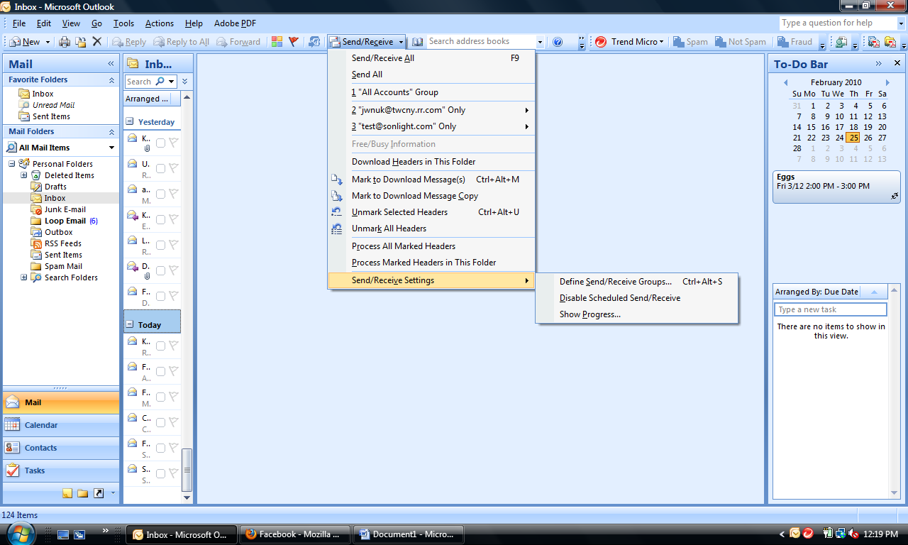

Hover your mouse over **SEND/RECEIVE SETTINGS …** then click **DEFINE SEND/RECEIVE GROUPS** …

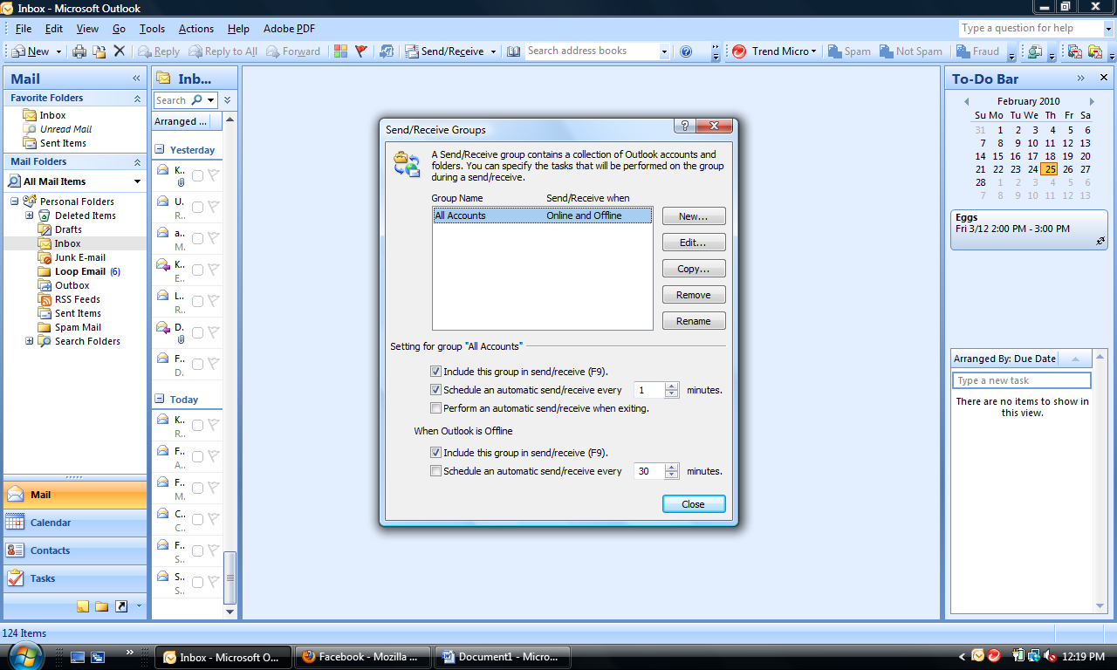

Click the **EDIT** button …

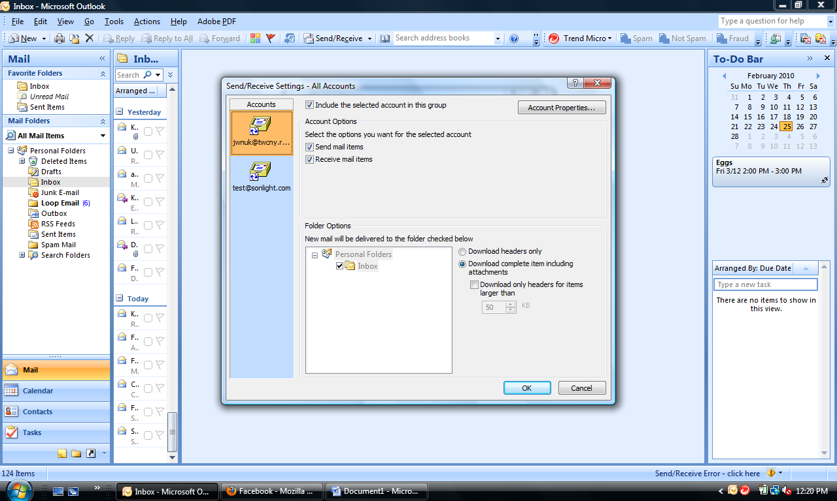

In the **ACCOUNTS** column … click on your Sonlight email account …

**UNCHECK RECEIVE MAIL ITEMS** …

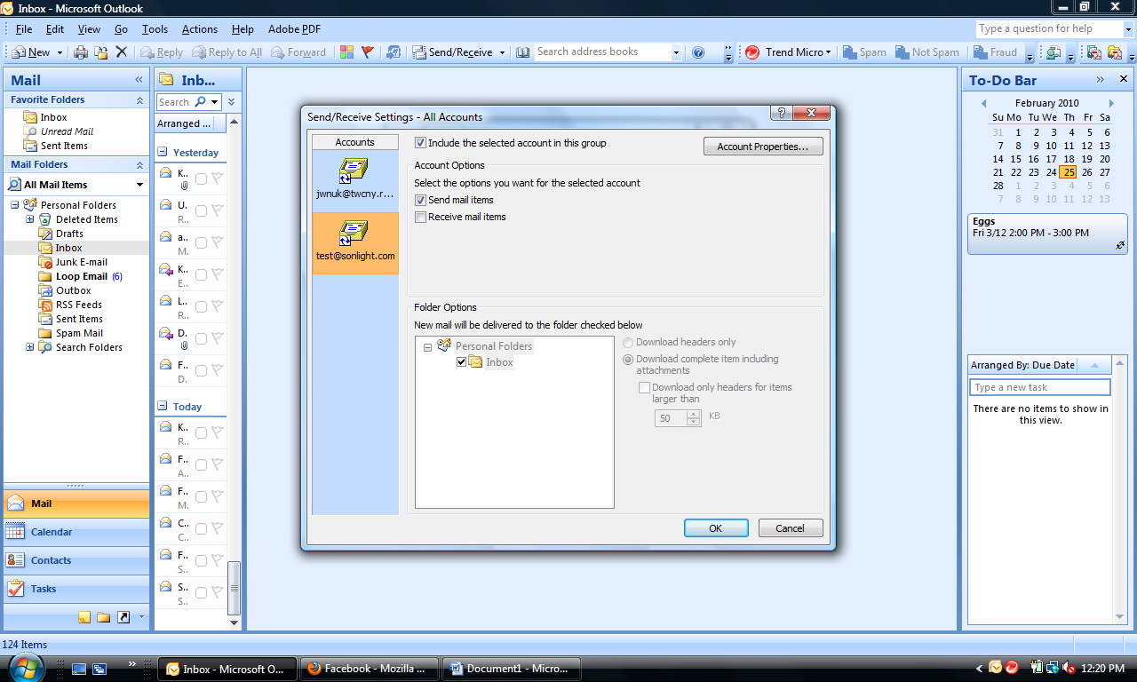

Click **OK …**

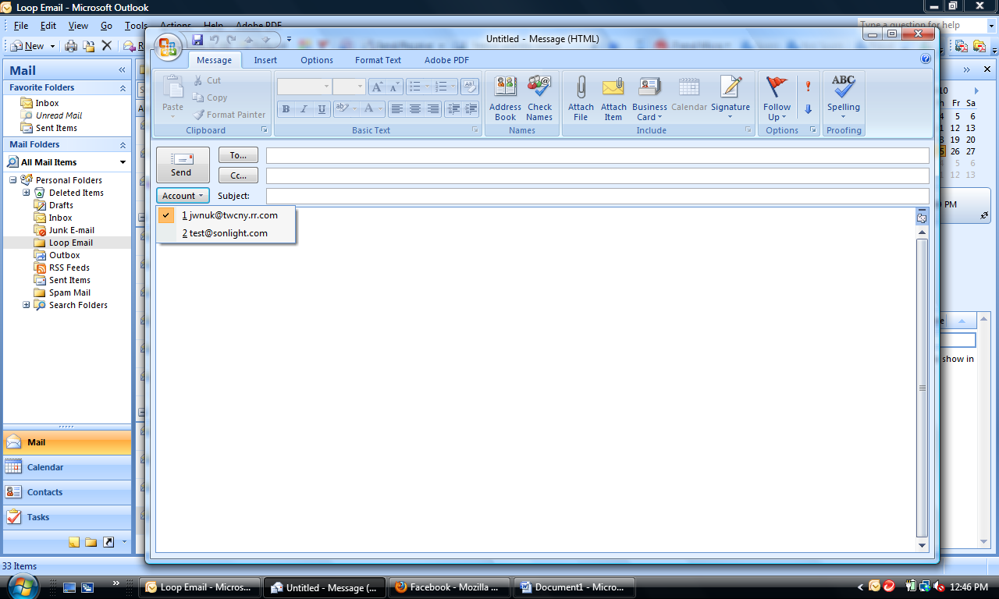

Open a new email … click on the **ACCOUNT** button … choose your Sonlight email address … you’re all set!