
Here's your latest new "Special Offer Alert" from Sonlight...
As a subscriber, you get this email alert to let you know about new resources, sale prices, clearance items, and other promotional events BEFORE Sonlight offers them to anyone else. And remember, if ever you'd like to stop getting this alert you can tell us by clicking the link at the end of this message.
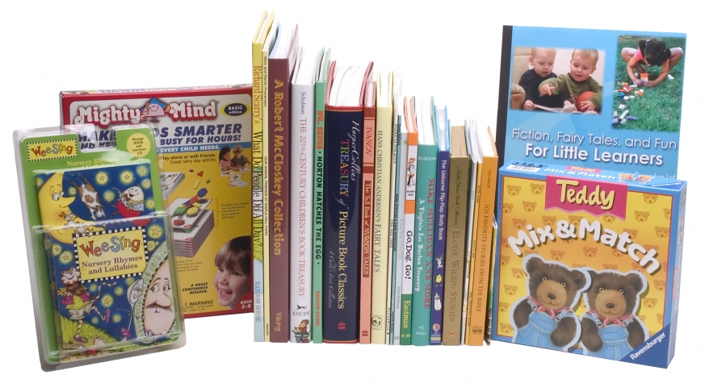

Fiction, Fairy Tales & Fun for Little Learners
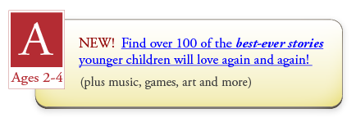

Announcing: Sonlight Level A has arrived!
Simply satisfy your toddlers’ inquisitive hunger with over 100 of the most engaging, colorful stories we’ve found. Best of all...
Not a workbook or “lesson” in sight.
Together, you’ll all enjoy these age-friendly books filled with poetry, fables, and true stories from history and the Bible. Sonlight Level A (for ages 2-4 years) also includes over 78 nursery rhymes and sing-alongs on CD, games that build mental skills, supplies for creative art time, and more!

Your Parent’s Companion makes “teaching” your toddler as easy and rich as you want it to be:
You can enjoy Level A by just cuddling on the couch and reading with your children. But if you’re like most Sonlighters, you want to encourage them to delight in their “learning adventure.” So your special Parent’s Companion helps you:
- Fuel your child’s imagination and desire to know, with easy and creative ideas for every story included.
- Complement your own ideas with encouragement, inspiration and links to many more optional resources.
- Enjoy simple checklists to track your progress (no strict schedule to follow) and practical helps for your home.

Give your little ones quality time with the whole family, without stealing their natural love for discovery...
Read their favorite stories with them while big brother or sister tackles some independent work. Let them grow and learn on their own too, while you enjoy more focused (sometimes even distraction-free) teaching time. Even encourage your older ones to use these easy books and fun activities to bond with “little sister” (or brother).
Give your children new favorites they’ll read over and over, and keep as treasured “special friends.” Build a library you’ll pass on to generations.

Fiction, Fairy Tales & Fun for Little Learners
When you order Sonlight Level A, you’re also automatically a full “Core” Member of the Sonlighters Club, with all the perks:
- 10% savings on every order for a full year!
- Pay no shipping (domestic to US/Canada) for one year
- Exclusive Thank-You Gift: FREE genuine ancient Roman “Widow’s Mite” coin set in a lovely silver pendant ($39.99 value)
- Sonlight’s “Love to Learn” 100% Risk-Free Guarantee:
Try Sonlight Level A for 12 full months—use up to half the program and return it for a full refund if you’re not thrilled with it, no questions asked.
- Complimentary 2-year Membership in Sonlight’s Online Forums—a warm, vibrant homeschool community! ($54.99 value)

Enjoy your little ones, and invite them to share your love of learning...

The way you wish you’d been taught. Guaranteed.SM

Thanks for reading this new Sonlight Email Alert!
Sincerely,
Ken Grindall
Special Offers & Promotions,
Sonlight Curriculum, Ltd.


