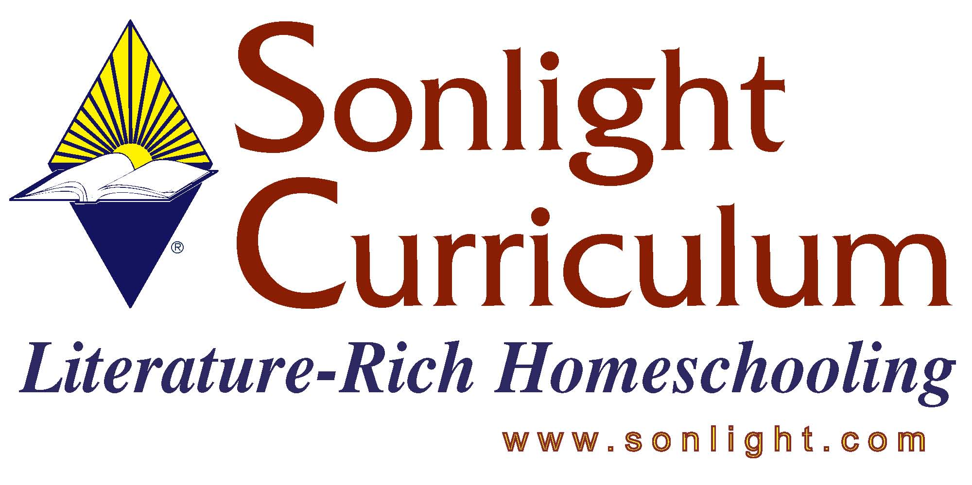

STC 2005 – Product Fact Sheet

COME LOOK WITH ME series
Reviewer: Gale Wightman

PRODUCT AUTHOR OR PUBLISHER: Blizzard
PRICE: $15.95/book; 4 books total

APPROPRIATE AGE RANGE OR READING LEVEL: The book is designed for an adult to read and discuss with a child (approx. preschool through elementary school)

What is included in this product? The book.

Any special requirements necessary for using/teaching this product: None.

Give a 4-5 sentence description (or bullet points) of the goals or concepts this product teaches …
- Introduces great works of art to children;
- Helps children to look at art with more depth than, “That is a nice picture.” i.e. “List three words that describe the sky in this painting.”
- Information about the artist can be paraphrased to the child;
- The questions are open-ended so there are no right or wrong answers. It helps kids formulate opinions and learn how to express their ideas.
- The book introduces art from various time periods, including 20th century art.

How do you fit this into a school day/how do you schedule this product:
We would do a painting a week, and then sometimes reproduce something from the painting in a craft time.

How much parental involvement? How much student time required at each session?
10-15 minutes of book time. I would lay out materials for my child, but then let her work on a project while I did other things.

Name two or three things you feel it is important for customers to know about this product before they purchase?

- There are no answers. So if they need to know what they think is “right” they would be frustrated.
- For people looking for more hands on activities, this would be a great book to introduce them to as many young artists practice by copying works of other artists.
- Learning how to analyze art is a great skill, and this can be taught at a very young age.

