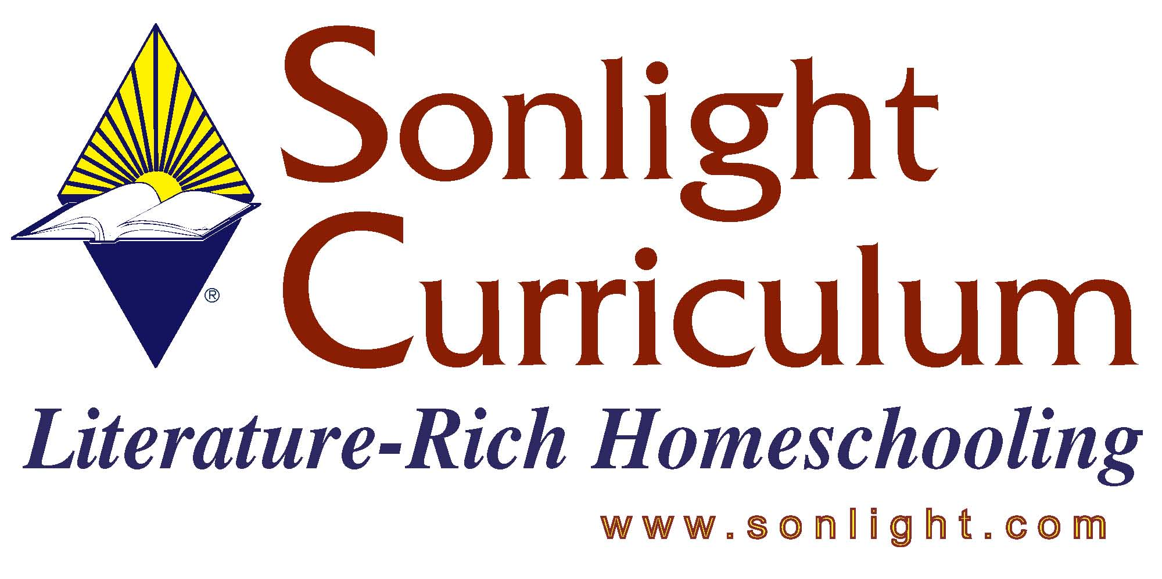

STC 2005 – NEW Product Fact Sheet

HOMESCHOOLERS’ COLLEGE ADMISSIONS HANDBOOK
Reviewer: Judy Wnuk

PRODUCT AUTHOR OR PUBLISHER: Cafi Cohen, author; Prima Publishing
PRICE:

APPROPRIATE AGE RANGE OR READING LEVEL: Jr. High and above

What is included in this product? Paperback, 321 pages

Any special requirements necessary for using/teaching this product: None

Give a 4-5 sentence description (or bullet points) of the goals or concepts this product teaches …
- Answers to your questions, including how to:
·Decide what type of college is right for your homeschooler
·Develop the proper college-preparatory curriculum for your child
·Learn what colleges expect from homeschooled applicants
·Prepare your homeschooler for the admissions process
- Testimonials from homeschoolers who have graduated high school students
- Testimonials from high school grad’s
- Multiple samples (i.e. transcripts, portfolio contents, resumes, recommendation letters, etc…)
- Timelines for college planning
- Pointers for college admission testing

How do you fit this into a school day/how do you schedule this product: Parent/Student resource

How much parental involvement? How much student time required at each session? N/A

Name two or three things you feel it is important for customers to know about this product before they purchase?
- Exceptionally practical, easy to read suggestions and ideas for college preparation
- Bulleted lists outlining the most important points of each section
- “How We Did It” testimonials from homeschoolers in all walks of life
- Great chapter on what “counts” for credit in high school

