**Booth Set-up Cheat Sheet**

**(Matching tablecovers with vertical banners)**

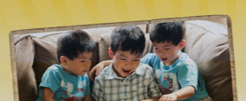 **New To Sonlight banner (Newcomer table)**

 **Why Sonlight banner (center table)**

 **Need Flexibility banner (right-hand table)**