*After-Convention Workshops*

These are not home parties but rather workshops that can be held in the home or another facility. Lynn has been offering these for many years and they have demonstrated significant benefit in retaining customers and building loyalty.

**Why?**

* Increased customer loyalty
* Better customer retention and repeat business
* Obtain referrals (workshop offered free, ask for referrals in return)
* Increased referrals brings new business
* Save time in the booth AND after a convention (serve many at once)
* Increase the customer’s knowledge base
* Closer look and training on Instructor’s Guides
* Encourage add-on sales of Electives
* Less return of products
* Marketing creates larger $ per order
* **Bottom line = increased sales**

**How?**

* Plan … set a plan, know the plan, establish goals, and keep the plan in motion

Consider: Who will attend?

How do people find out about the workshops?

How do I motivate people to attend?

* Print … your advertising needs to be offered in a variety of forms (see below)

Post your workshop dates on everything

* Keep it PROFESSIONAL – this is not a “home party”

Providing training for Mom’s success

Recommend not allowing children – no distraction, value for all attending

* Schedule it

Can use genbook.com – check it out at lynnwoodley.genbook.com

Set dates and tell everyone, including customers on phone consultations

Send reminders 1 week prior, request confirmation of attendance

* Hand out print advertising, promote on website and blog

Create emotion value – limit group size, place $ equivalent on free session

**Examples of Advertising**

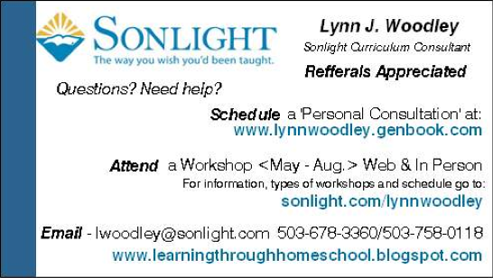Business ‘Information’ Cards front and back (inexpensive from Vista Print)

Post Cards (print 4 per page on card stock and then cut apart – less cost than postcard paper)

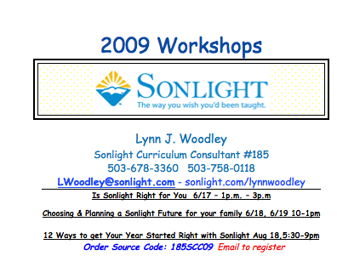

Side one – Workshop information



Back Side – Reasons we love Sonlight

Catalog Letter – Back Side/Front Side, printed half sheet size

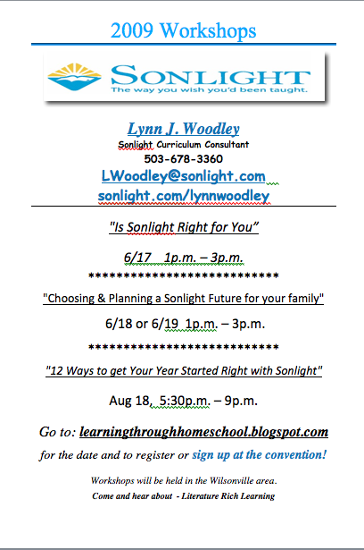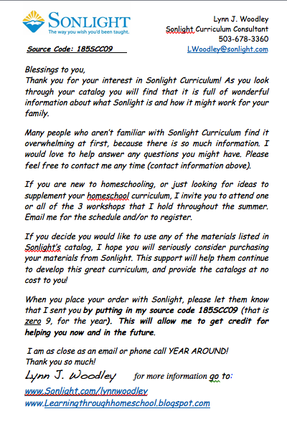

Workshop sign up sheet (Excel worksheet) – full page for each workshop session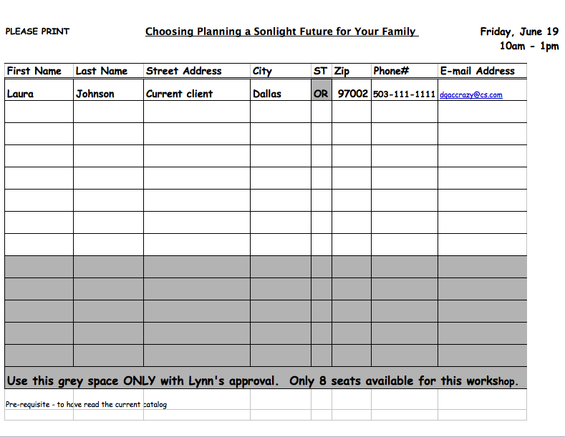

Place in ½” binder with full-page schedule (example below) in front and back view pockets

* Train assistants to sign people up for the workshops
* Creates commitment for attendees
* Gives you an e-mail to send them a reminder the week before the session

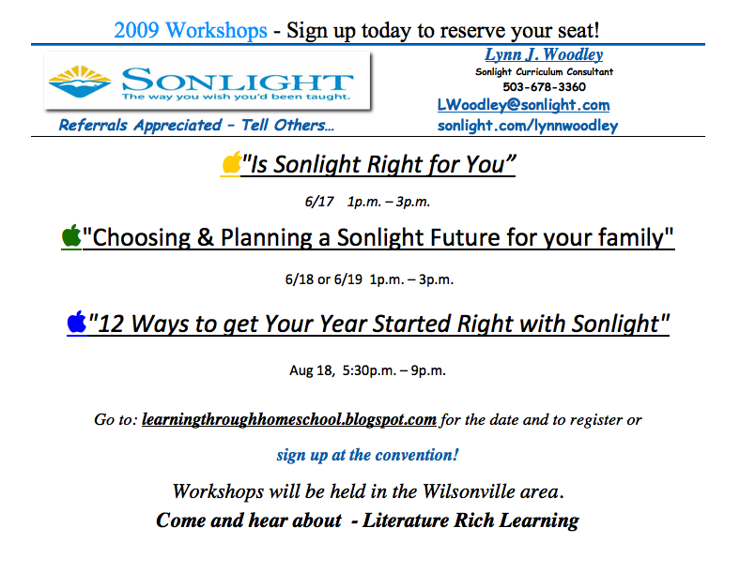

Talk it

Blog it

Put the schedule

on your blog

**Where/When**

* Church
* Conference room
* Library
* Restaurant meeting room
* Online: Skype or Webinar
* Home

Schedule - Set up in pre season

Workshops 1, 2 and 3– schedule shortly after each convention

Workshop 4 - A couple of weeks before start of school year

**What**

#1 **Is Sonlight Right for You**

2 hours

Scheduled after each convention

Open seating attendance – the more the merrier

Web based – may have a limit of ‘seats’ (24 max. for Skype conferencing)

This workshop is giving them general information on where Sonlight came from, why it is effective, and how it can fit into their lives.

**#2 Choosing and Planning your Future with Sonlight**

3 -4 hours

At least one after each convention

Display as many Core programs as possible, along with Sci and Electives

Limited Seating - no more than 8 – to allow greater interaction

This workshop is exactly what it says. Being able to choose what you need because you have had the chance to go through everything, especially electives. It also is a workshop that helps them plan their future through High School using Sonlight.

**#3 High School**

3 hours

Covering requirements, testing, transcripts, diploma (Basic Skills Nation Wide), electives

This workshop is to help the high school parent know and understand what their child needs to complete their high school requirements, and understand the state standards. This one will help them see that Sonlight does have most all of what they need.

**#4 12 Ways to get your Year Started Right with Sonlight, 4-5 hours**

4-5 hours

Helps gather their thoughts and gives confidence

Helps them get organized – encourage attendees to bring their new IGs to assemble

This workshop is a kick off to the year, with support, helping them see that they can succeed and are supported by prayer. Opportunity to network a bit with other attendees, and mostly to give them confidence, to be successful in their year. Builds loyalty and Sonlight friendships