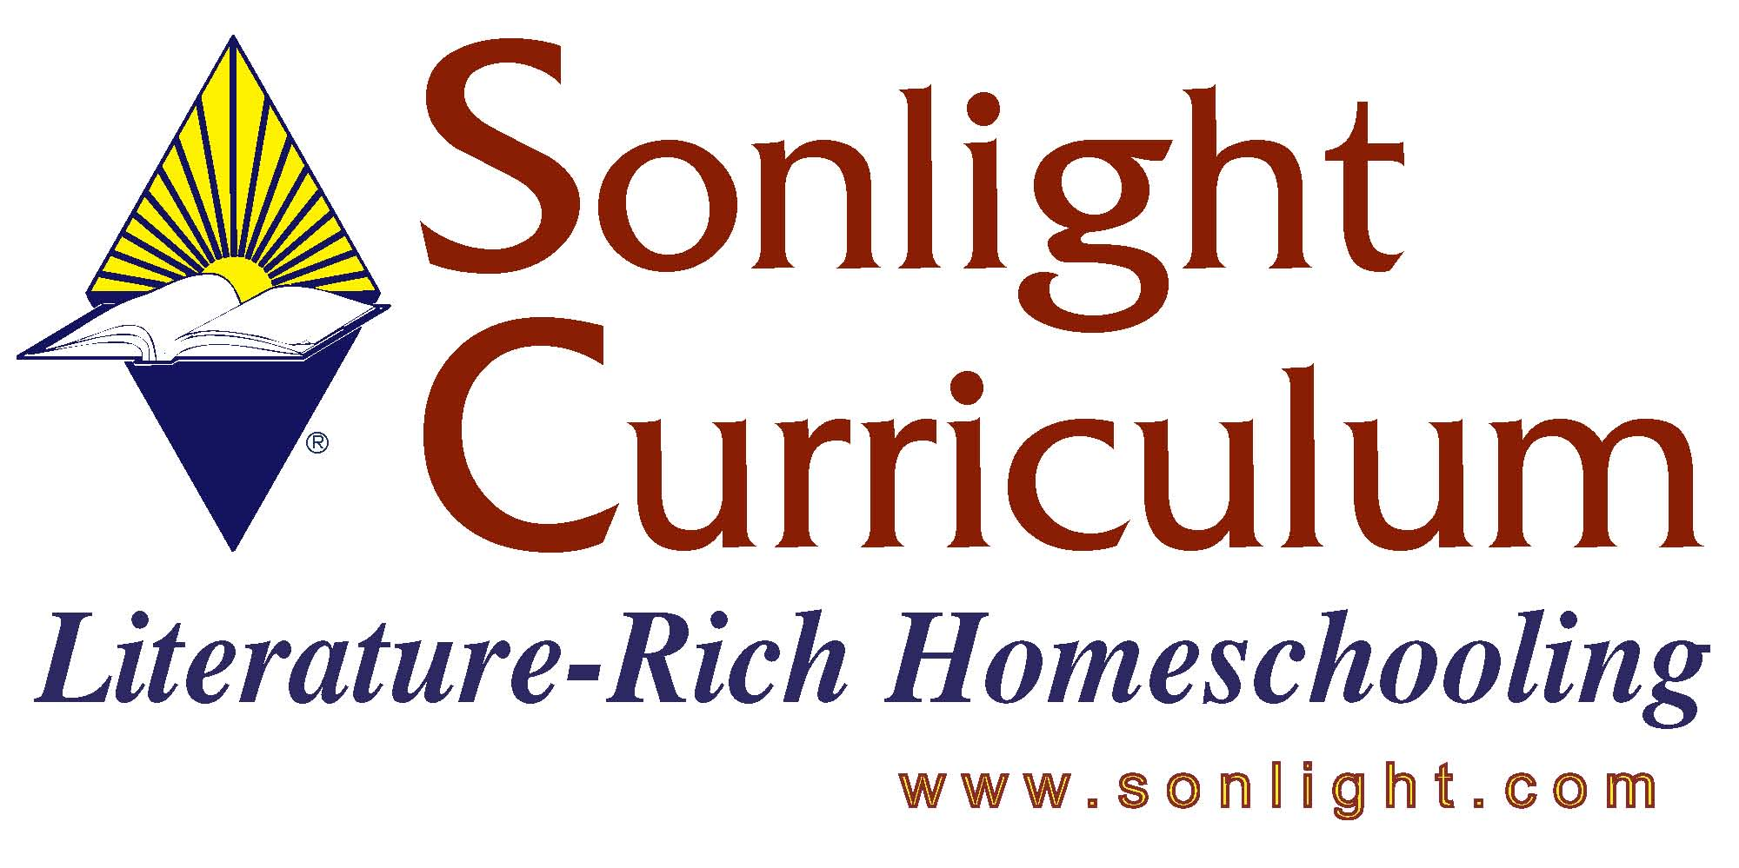
Please feel free to email me again if I can be of further assistance. Thank you for the opportunity to assist you today!
Blessings,
Judy Wnuk
Customer Champion
TITLE: Artistic Pursuits SR High Book One – Elements of Art & Composition
Presenter – Judy Wnuk

PRODUCT AUTHOR OR PUBLISHER:
PRICE: $

APPROPRIATE AGE RANGE OR READING LEVEL: Grades 9-12

What is included in this product? Spiral bound book

Give a 4-5 sentence description (or bullet points) of the goals or concepts this product teaches …

This 2nd edition book contains 16 units and features European Art. The book begins with a complete supply list.

Each Unit includes:
- Vocabulary & creative exercise page. Definitions of terms are introduced both verbally and with an illustration. A creativity exercise is included with complete instructions. The objective is set apart in a box.
- Art appreciation page. The topic of the unit is demonstrated by a work of a master artist. The page highlights the concepts as they are seen in the art work.
- Art history page. Primarily text to read on art culture or an artist biography. Includes a challenge for the student to complete.
- Techniques page. This is the “how to” portion of the unit. Students practice the techniques by following the written and illustrated instructions.
- Final project page. Students create a work which demonstrates the information they’ve learned from the unit. Includes a materials list. Students finish by evaluating their work (“look back”).

Media Introduced: 3 grades of pencil, vine charcoal and compressed charcoal.

Grading: Evaluation sheet provided for determining a number and letter grade.

Scheduling: This program is designed to be covered in one year with 2 classes per week for about 32 weeks. Lessons are intended to last approximately one hour.

2008 FAQ

