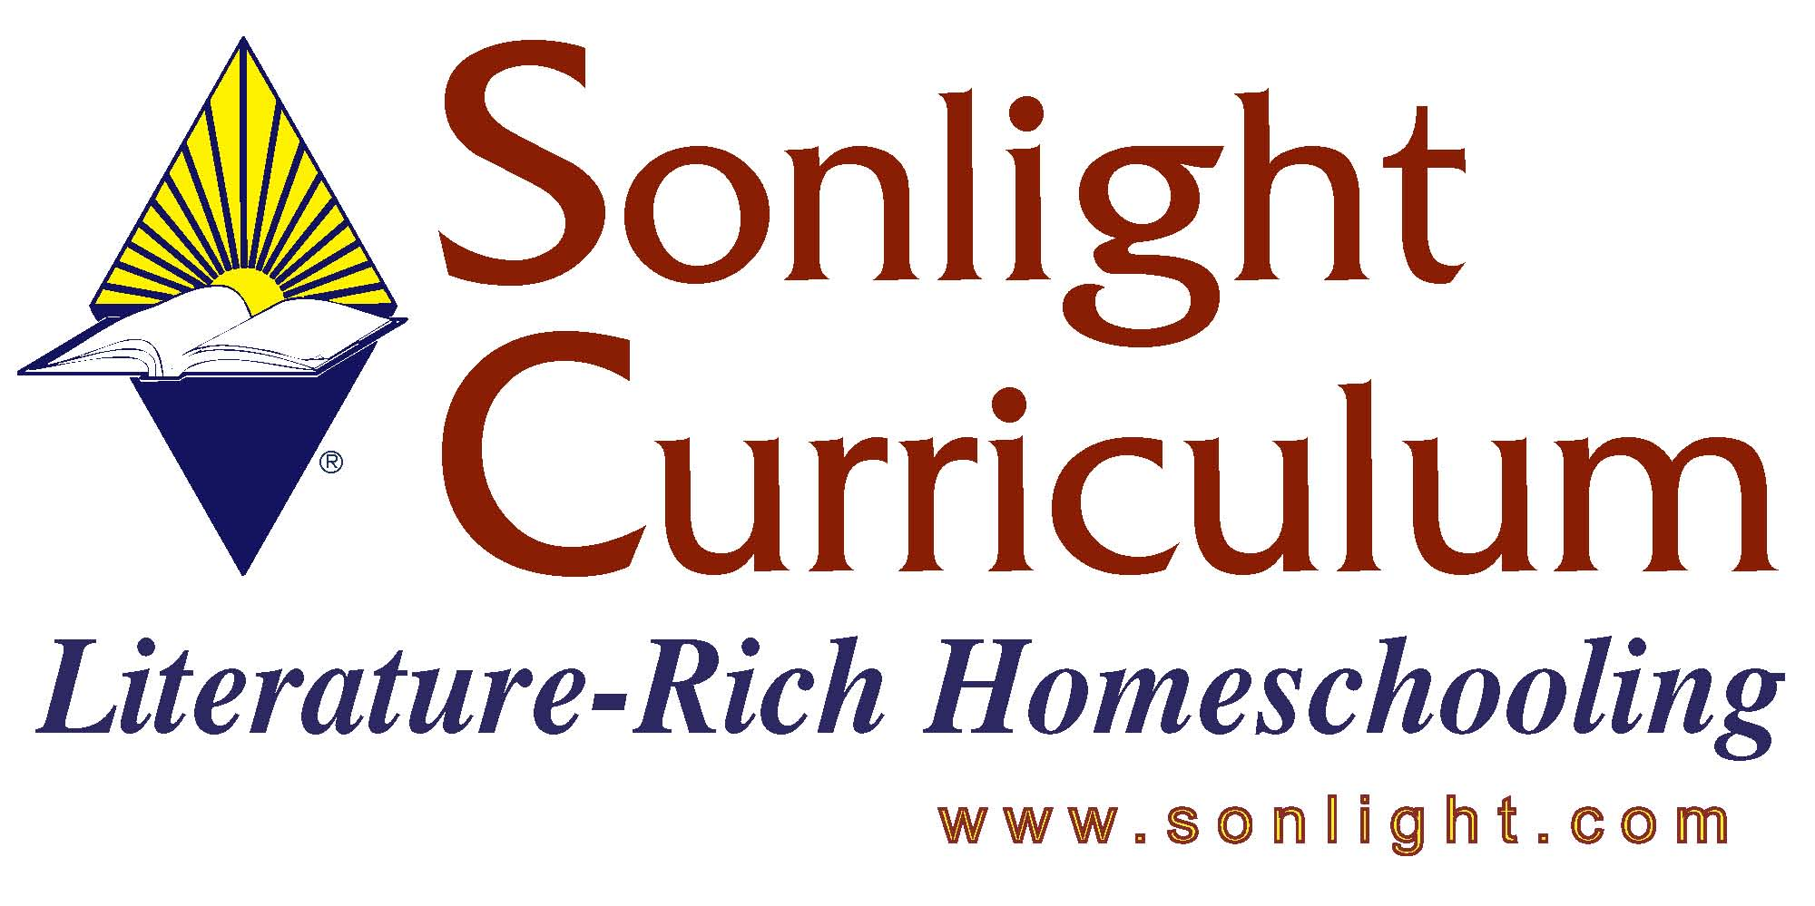
Please feel free to email me again if I can be of further assistance. Thank you for the opportunity to assist you today!
Blessings,
Judy Wnuk
Customer Champion
TITLE: Artistic Pursuits Grades K-3 Book One – Introduction to the Visual Arts
Presenter – Judy Wnuk

PRODUCT AUTHOR OR PUBLISHER:
PRICE: $

APPROPRIATE AGE RANGE OR READING LEVEL: Grades K-3

What is included in this product? Spiral bound book

Give a 4-5 sentence description (or bullet points) of the goals or concepts this product teaches …

This 2nd edition book contains 32 Lessons prefaced by a complete materials list. The lessons are broken out in three sections … What Artists Do, What Artists See, and Where We Find Art.

Each Lesson includes:
- A one page explanation with illustrations. It includes the goal of the lesson set off in box (i.e. This lesson teaches us …).
- A one page art appreciation lesson which usually includes a work of art by the masters. Questions are included (no answers) to stimulate a student’s thinking and appreciation of art.
- A one page project which includes a list of needed supplies and step-by-step instructions with illustrations.

The book ends with a “Congratulations” certificate for the parent/teacher to fill out for the student.

There is parent/teacher information in the back of the book which includes “motivators” for art (i.e. ideas for encouraging students in their art work).

This book introduces: ebony pencils, pastel sticks, oil pastels, watercolor crayons, colored paper craft, and clay.

2008 FAQ

