The 20th Century Day by Day

The 20th Century Day by Day, published by DK, is now on CD ROM instead of a book. The CD still has all of the same information to answer the questions in your study guide. Once you have setup your CD on your computer, open the application. When you enter the program, you will see a graphic of a newsroom. To get started, click on the red, oval navigator button in the top left corner. The navigator will display a menu at the top of the screen. Stop and read your history schedule.
The first day on your schedule, directs you to look at the pictures on pages four and five of the book. These pictures are no longer available. Use your first day to become familiar with the program. Select the various buttons to see what they do. You may even want to take the “Random Tour.”
Your schedule also instructs you to answer questions about the time period of January to June 1900. Select the calendar icon from the menu. Then, click the year 1900 and begin with January. Read your first question from your study guide.
When is gold first discovered in the Canadian Klondike? ➔
The timeline is located at the bottom of the screen. You can see this in figure 1.1.
The graphic of the screen should appear here. We need copyright privileges to use a graphic of the screen. In the meantime, I have a diagram to illustrate the screen. I have the tentative graphics at the bottom of this page.
On the timeline, you will see the words gold and Klondike along with a graphic. Select it and the article will appear in the main window. The answer to the first question is under the title “Town Prospers.”
Your next question is February 1: What is the Boer War, and when does it begin? ➔
The date February 1 is on the timeline at the bottom. Select it to answer the question about the Boer War. Follow the same procedure for the March 14: What does President McKinley do to the American dollar? ➔
At this point, there seems to be a pattern. All you have to do is look on the timeline, right? Wrong. This is actually where the pattern begins. March 19 does not appear on the timeline.
March 19: Where is Knossos Palace, which archeologists excavate in 1900? ➔
The next date listed is April 10. Now what? You can do one of two things. You can go to the top right corner of the screen and click on News in Brief or you can look at the bottom right corner in the News Extra box.
- If you click on News in Brief, you can scroll down and find the date March 19. You will see a red and white box, which is a link to the article. Notice that only the dates for March 1900 are available. The News in Brief only shows the articles available for the month that appears at the top of the screen.
- If you choose News Extra, you will look for a key term or terms in the question and not the date. The key term for March 19 is Knossos Palace. For the month of March 1900, there are four extra articles. You can see the numbered articles at the bottom of the box. Before you touch anything, read the headline in red text. The headline changes as each number is highlighted. The first headline is “Relief of Lady Smith. “ The second is “Debs for President.” The third is “Evans Excavating Knossos Palace in Crete.” The key term Knossos Palace appears in this headline. This is the article that answers the question for March 19. Click on the title to bring up the article.

Follow the same procedure for March 24: When does work begin on the New York City subway? ➔

So far, at least one date from each month has appeared on the timeline. The date June 21 does not, but June 26 does. Even though you don’t have a question about June 26, select this article anyway because it will lead you to the correct month. You can also go back to the calendar and select June 1900.
June 21: Filipinos overthrow the Spanish colonial power. Who do they fight next?
Once you are on the June 1900 page, you can find the article by the date through News in Brief. You can also find it by key terms, like Filipinos and Spanish colonial, in the News Extra Box. In this case the article is entitled “MacArthur offers Filipinos Amnesty.”
The last question the year 1900 does not have a date.
What is the big technological advance in moving pictures?
The key term moving pictures does not appear in June 1900. This means that the answer is in the months July 1900 through December 1900 because the next question after it is from the year 1901. The answer is in the program, but you will need to scroll along the timeline to find it. It appears in December 1900 under the headline “Viewing Rooms for Films.” Only a few answers in the study guide need a little detective work like this. You can find most of the other answers when you use the News in Brief or in News Extra.
One last place to look for an answer is in the text box with the graphic on the far right column of the screen, called Stop Press. The date June 24, 1901 is one of only a few articles that appear in this area. A key term for this question is art or exhibit. If you scan the article, you can find the key word exhibit in the article “Studies in Blue.”

Month and Year
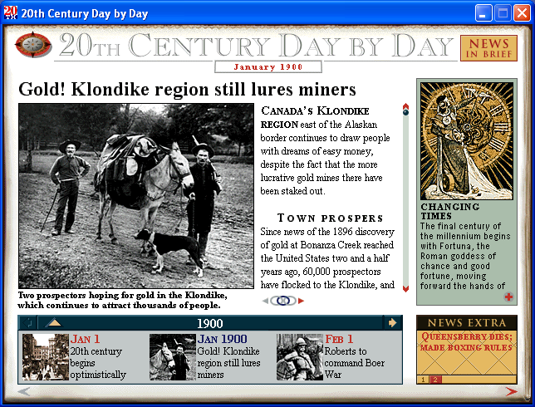
You can find more articles in these areas.
navigator

Graphic
Timeline with graphics
Stop Press
Graphic with text
News Extra
News in Brief
News Article
You can find more articles in these areas.
Month and Year
navigator

