

Sonlight Curriculum Consultant

Event Expense Request Form

Please complete the expense request form at least a month prior to your scheduled event. All of your event paperwork must be turned in or your check will not be mailed. Please send to Jessica at jbrown@sonlight.com.

SCC Information
SCC Name: |  | Date Submitted:
SCC #: |  | Phone:

Event Information
Event Name:
Event ID: |  | Event Date:

\

Expenses Requested
 | Qty | Amount
Number of Workers for one day :
(Including all adults and teens)
Number of additional days:
(Do not include day early set up in this figure)
Day Early Set up required:
(Put Yes or NO and the total amount for allowed people)
Any changes (i.e such as “only 2 assistants on Friday”) subtract the $ amount in the right column.
Total Amount Requested: | = $

*Note: Expenses will not be paid until all assistant profiles have been turned in.

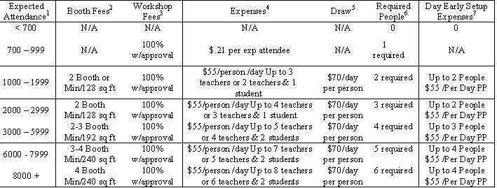

Pre-Registration REQUEST
Separate pre-registration check for 2009 |  | = $
Pay to the Order of:

Thank You!

